
UNIVERSITY OF HERTFORDSHIRE
School of Physics, Engineering and Computer Science
MSc Advanced Computer Science
7COM1039-0509 Advanced Computer Science Masters Project
02-09-2024

Final Project Report (FPR)

Resume Parser using Streamlit Framework

Name: Sanofer Sameena Riyas
Student ID: 22080596
Supervisor: Anish Saini

MSc Final Project Declaration

This report is submitted in partial fulfilment of the requirement for the degree of Master of Science in 7COM1039-0509 Advanced Computer Science Masters Project at the University of Hertfordshire (UH).
It is my own work except were indicated in the report.
I did not use human participants in my MSc Project.

Table of Contents
Abstract 6
1 Introduction 7
1.1 Research Question 9
1.2 Objectives: 9
1.3 Structure of the Report 9
2 Background: 11
2.1 The Role of NLP and Machine Learning: 11
2.1.1 Natural Language Processing Techniques 11
2.1.2 Machine Learning – KNN and SVM 13
3 Literature Review: 15
4 Methodology 20
4.1 System Architecture 20
4.2 Process Flow Diagram – Step-by-Step 22
4.2.1 Algorithm Implementation in Pseudocode 22
4.2.2 Algorithm for Resume Classification Flowchart: 23
5 Result & Analysis 28
5.1 Deployment 28
5.1.1 Resource Requirements: 28
5.1.2 Deployment Environment: 28
5.2 Development Process 28
5.2.1 Libraries and Their Roles 29
5.3 Results Analysis 30
5.3.1 Evaluation Metrics for Regression Models 30
5.3.2 Evaluation Metrics for Classification model 34
Bibliography 38
6 Appendix 41
6.1 Process Flow Diagram Code Implementation 41
6.1.1 Data Collection 41
6.1.2 User Upload Resume 41
6.1.3 Preprocessing & NLP Process 41
6.1.4 Feature Extraction & Vectorization 42
6.1.5 Machine Learning 43
6.1.6 Model Training 43
6.1.7 Predicting Score 44
6.1.8 Store Result in Database 45
6.1.9 HR Login and Review 46
6.2 Project Screen 47
6.2.1 User Screen 47
6.2.2 Feedback Screen 49
6.2.3 Admin Screen 51

Table of tables
Table 1 Literature Review Analysis 16
Table 2 Evaluation metrics for Regression model 33
Table 3 Discretization 34
Table 4 Evaluation metrics for Classification model 36

Table of figures
Figure 1 Working of Machine Learning Algorithms (Siva Jyothi, 2023) 8
Figure 2 Working of KNN Algorithm (Dadi, 2024) 14
Figure 3 Working of SVM Algorithm (Kumar Ajitesh, 2023) 14
Figure 4 System Architecture for Resume Parser 21
Figure 5 Resume Parser and Classification System 25
Figure 6 Mean Absolute Error Comparison by Model 31
Figure 7 Root Mean Square Error Comparison by Model 32
Figure 8 R2 Comparison by Model 32
Figure 9 Accuracy Value 34
Figure 10 Precision Value 35
Figure 11 Recall Values 35
Figure 12 F1-Score Values 36
Figure 13 User Uploading Resume 47
Figure 14 User Resume Analysis 47
Figure 15 Skills Evaluation 48
Figure 16 Course & Resume Tips 48
Figure 17 Resume Score 49
Figure 18 Feedback Form 50
Figure 19 User rating Pie chart 50
Figure 20 User Comment Table 51
Figure 21 Admin Login Interface 51
Figure 22 Admin view filtered resume’s report 52
Figure 23 Feedback Data 53
Figure 24 Predicted Field according to the Skills 53
Figure 25 User's Experienced level 54
Figure 26 Resume Score 54

Abstract
Resume parsing is a part of recruitment where resumes are processed and extracted for candidate screening, so All companies search their database to get some information on potential candidates. While the inception of machine learning technologies, automated parsing resumes become more prevalent as it enables businessmen to process large numbers off resume in a speedy and accurate by that meant. In this project, we did a thorough review over all the resume parsing methodologies using machine learning along with our purposed architecture for better performance in resume parsing. As most organizations rely heavily on resume parsing for their recruitment solutions, the review started with an introduction of modern recruiting practices that led to this method and why they are so vital when hiring talent. That quickly transformed into discussions around manual methods typically used in a founded workflow (like CVs), how time-consuming could be properly interpreting everything within them, plus all negative ways human error(s) & inconsistency applied experience — resulting not just poorly drafted resumes but lost interest amongst otherwise interested candidates too!! It then gives a summary of the traditional rule-based parsing techniques, and specific reasons why they are inadequate at processing wide-variety resume formats in different languages or having varied structures. Following which, in detail the abstract talks about machine learning technologies like natural language processing (NLP), deep learning and how they can be used as a piece of automation. It highlights the merits of using these technologies to enhance resume parsing accuracy and flexibility towards advanced resumes' comprehension methodical information surrounding differently formatted presentations. This Project provides a new strategy that how we can improve the performance of parsing by combining machine learning algorithms with context and semantic analysis. The new framework is primarily focused on solving some of the issues in prevailing systems and hopes to provide a comprehensive, scalable alternative that can change how recruiting industry functions. This instalment also investigates the potential effects that enhanced resume parsing may have on recruiting functions, candidate interactions and overall organizational productivity – further solidifying how future breakthroughs in this sector continue to be of utmost importance.

Introduction
In recent times, the screening of resumes has become a major problem for Human Resource (HR) department in recruitment especially for the fact that each job opening gets lots of applications. Traditional ways of reviewing resumes are time consuming, and they have room for human errors and prejudices, hence inefficiencies in the hiring process. Traditional resume analysis methods are largely based on rule-based systems and keyword matching, but provide basic automation, but are limited in the management of different formats and languages. A rule-based system often lacks the context and relevance of information and can produce incomplete or incorrect analysis. On the other hand, manual analysis is labour intensive, subject to human errors and biases and invariable, making it more and more impractical as the number of applications increases.
The importance of resume research in today's hiring process cannot be exaggerated. With the increase in job applications, manual resume reviews are becoming impractical for recruits, as they require time and are susceptible to human errors.
Resume Parsing (RP) refers to the automated mechanism now used by organizations to screen applications and process the talent acquisition strategy. The increasing volume of job applications received by every organization has slowed down the process of HR departments manually screening resumes. The analysis of resumes is an essential step in the hiring process because it extracts important information from resumes such as contact details, education, experience and skills that are frequently required for the selection and selection of candidates.
Recent research has provided sufficient evidence of the disadvantages of manual resume analysis, particularly in studies such as Sajid et al. (2022). Integrating machine learning algorithms, including those studied by Chavare and Patil (2023) using Spacy Bhatia et al. (2019) using BERT for sentence pair classification, and Ayishathahira, Sreejith and Raseek (2018) employed CNN and Bi-LSTM-CNN for sequence labelling, can assist in the classification of resumes and ultimately enhance the recruiting process in its entirely. However, on certain occasions, the existing systems lack a module that has sufficiently evolved for advanced classification or a user-friendly interface.
The aim of this project is to develop a parsing and classifying resumes using NLP to extract necessary information from resume by use of machine learning algorithms such as KNN and SVM categorise the parsed information. The user interface will be built to incorporate the different elements utilising the Streamlit framework.
Natural Language Processing (NLP) is an artificial intelligence¹ subfield concerned with the interaction between human languages and computers. It’s a broad field, and it comprises tasks such as text cleaning and preprocessing, part-of-speech tagging, named entity recognition, sentiment analysis, machine translation, text classification and language modelling. NLP also includes, emission recognition and text generation, question answering, information extraction, and dependency parsing. The purpose of NLP is to enable computers to understand, generate and work with human language, using methods from machine learning, deep learning and statistical approaches. There are several applications connected with NLP, such as chatbots, translation services and automated content generation.
¹Artificial Intelligence (AI) is an area of computer sciences that emphasizes the creation of intelligent machines that work and reacts like humans.
On the other hand, Machine learning (ML) is the one of the technologies which built to become smarter gradually as they use an experience. It allows computer systems to learn data without programmed them explicitly. Machine learning uses algorithms that allow computer programs to structure and build learning data then predict information based on historical data or information that change overtime. The term machine learning was first introduced by Arthur Samuel in 1959. “Machine learning enables a machine to automatically learn from data, improve performance from experiences, and predict things without being explicitly programmed”.
A Machine Learning system learns from historical data, builds the prediction models, and whenever it receives new data, predicts the output for it. The accuracy of predicted output depends upon the amount of data, as the huge amount of data helps to build a better model which predicts the output more accurately. Suppose we have a complex problem, where we need to perform some predictions, so instead of writing a code for it, we just need to feed the data to generic algorithms, and with the help of these algorithms, machine builds the logic as per the data and predict the output. Machine learning has changed our way of thinking about the problem. The below block diagram explains the working of Machine Learning algorithm:

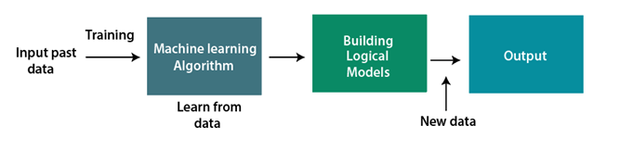
Figure 1 Working of Machine Learning Algorithms (Siva Jyothi, 2023)
Features of Machine Learning:
- Machine learning uses data to detect various patterns in a given dataset.
- It can learn from past data and improve automatically.
- It is a data-driven technology.
- Machine learning is much like data mining as it also deals with the huge amount of the data.
There are two important machine learning algorithms that helps in resume parsing:
The K-Nearest Neighbors (KNN) algorithm is a useful and simple machine-learning algorithm that can be KNN can be applied to both classification and regression problems as it’s based on the principle of similarity. For a new data point, KNN finds its K nearest neighbours in the training dataset and uses their labels/values to make predictions for the new point.
Why it helps with parsing resumes: KNN works well in parsing resumes because it performs classifications on the smallest entities of the résumés according to their similarity to past examples. For example, if the training data is composed of résumés classified in different categories, KNN's classification of a new résumé will extract the most similar résumés of the training set, and it will assign it the most probable category. This relies on the heuristic that similar résumés (in terms of the skills, the experience, etc) could belong to the same category, which can help in the category's classification process.
Support Vector Machine (SVM) is a powerful supervised machine learning algorithm primarily used for classification tasks, though it can also be applied to regression. SVM is renowned for its ability to handle high-dimensional data and its versatility in different applications.
Why it helps with parsing resumes: An SVM finds the optimal partition boundary (hyperplane) to separate resumes of one class from those of another class. This is exactly the case when resumes are classified into technical, management and creative job roles, or the like. In such a scenario, SVM can separate the different classes of resumes more accurately by finding the decision boundary that best partitions the data points in a multidimensional space.

Research Question
Keeping these techniques in mind, the research of this project is motivated by following research question
How to mix Natural language processing algorithms (NLPs) with system getting to know algorithms (MLs) which include K-Nearest Neighbours (KNNs) and Support Vector Machines (SVMs) to offer efficient and accurate performance analysis and classification on inside the recruitment method?

Objectives:
To achieve the aim, the project has several specific objectives:
Data Collection and Preparation: Obtain an efficient resumes’ dataset from Kaggle focusing on many resumes in the range from 300 to 500. Data should be cleaned adjusting formats and looking for errors the most important fields for analysis should be tagged into contact info, education, experience, skills.
System Integration and Interface Development: Develop a simple web interface using the example Streamlit library for end HR professionals to upload resumes and visualize parsed and classified data in real time. Make sure to integrate NLP and auto learning models into the Streamlit layer for easy processing and interaction.
Implementation of NLP Techniques: Use Named Entity Recognition NER, to distinguish the key entities’ by extracting from resumes. Tokenization, to break down the text into smaller and meaningful components.
Text Categorization, categorize different sections of the resumes more effectively. Phrase Match: using some pre-defined phrases to accurately fetch structured data in a formatted manner from unstructured text.
Development of Machine Learning Models: Train K Nearest Neighbors KNN and Support Vector Machine SVM models on the pre-processed dataset to cluster resumes based on job roles and accomplishment levels. Optimize the models to attain high accuracy.

Structure of the Report
The report is divided into several main sections, each describing a particular aspect of the project.
Introduction: The background and the problem statement of the project, the objectives, the research question, the significance of the study are all described here. This part explains the context of the work, while the rationale statements justify why the selected methodologies are used.
Literature Review: Here is where you cite existing research and theoretical concepts related to the project. Here you are discussing the current state of the field by referencing previous studies related to resume parsing and classification (using NLP and ML methods) and how the current project is filling existing gaps in the literature.
Methodology: The methodology details how the data set was created from the text of Wikipedia, how some NLP was applied (tokenising the text into words, identifying named entities), which machine learning algorithms (KNN, SVM) were used to identify missing hyperlinks, and then how all the tools and techniques were connected to build the system.
Implementation and System Design: The architecture of the system, including the UI framework (such as Streamlit) used to design the system. This section is concerned with the details of the system: what is running in the background, what piece of data goes to where, and how do users go through the system.
Results and Discussions: The results of the project are presented in this section, including performance indicators of machine learning models, the analysis and labelling of resumes, and the discussion of the findings from the perspective of the research question and the objectives discussed in the introduction.
Conclusions and future work: The report ends with the conclusion that came from the study and what it means for the future study including defining what future work means – and that is the areas one should work on when preparing to write another article or finish the proceeding of studies. This includes getting farther in the limitation of the project and the consequences of the whole findings.
References: A comprehensive list of all the sources and references used throughout the report.
Appendices: For supplementary data, code snippets or elaborations, we use appendices as ancillary aids.

Background:

The Role of NLP and Machine Learning:
There are two potential solutions to the mentioned problems of resume parsing and classification – Natural Language Processing (NLP) and machine learning (ML). NLP techniques make it possible to automatically parse unstructured text and extract information available in resumes, such as names, contact details, educational information, work experience, tracks, and skills. Then the parsed structured data can be used for further analysis.

Natural Language Processing Techniques
Natural Language Processing (NLP) techniques such as Named Entity Recognition (NER), Tokenization, Text Classification and Regularization play an important role in automated resume parsing.
Named Entity Recognition (NER): NER is a simple but crucially important NLP technique that identifies and classifies entities in text into predefined categories such as person names, organisation names, location names, dates and more. One application of NER is automatically parsing through resumes; it can help to extract candidate names, college names, job titles and company names and classify them properly. For example, NER is useful to differentiate between ‘Harvard University’ as an institution of higher education and ‘Microsoft’ as a company so that all the extracted information is classified and utilised correctly. For a recruiter, seeing all the educational backgrounds of a certain candidate put in one line and all the companies worked at in another line can greatly simplify resume analysis.
NER typically involves several steps:
- Preprocessing: Text cleaning and normalisation (remove punctuation, convert to lower case, handle diacritics).
- Tokenization: Text is split into tokens, which can be words or phrases.
- Part-of-speech tagging: Each token is assigned a specific part of speech (e.g., noun, verb, adjective).
- Entity Recognition: Identifying certain predefined entity categories, like names, locations and organisations, that occur in our texts. We do this using model such as Conditional Random Fields (CRF) or deep learning approaches such as BiLSTM-CRF.
Typical issues with NER for the use case of resume parsing include limited typing variants for entities, use of abbreviations and words spanning across lines, lack of well-documented entities in training datasets, etc. However, diversity training datasets (with reasonable annotation efforts) and transfer learning will further improve NER models on a continuous basis.

Tokenization: Tokenisation is a method of converting text into smaller units, such as words, phrases or symbols called tokens, allowing the analysis and processing of the structured sentiments into machine learning ready chunks. For example, in the resume parsing industry, tokenisation splits the resume contents into smaller pieces such as separating words from a job description and dividing sentences into words. Tokenization is the first step in a more complex and advanced text processing technology to segment text into different components before the real emotion analysis begins. This helps the system understand all the text, not only bits.
There are different types of tokenization:
- Word Tokenisation: Splitting text into words, which is easy for languages like English that have word spaces, and harder for others (Chinese).
- Sentence Tokenisation: The division of text into sentences (identifying where sentences start and end in an input).
- Sub word Tokenization: Cutting up words into smaller units (sub words), which is useful for handling low-frequency words and morphological variations.
Tokenisation must be able to handle edge cases, such as the way that contractions, hyphenation, spelling differences and punctuation must all be dealt with properly to appropriately tokenise text.
Text Classification: Text Classification refers to functions of categorising textual data into pre-defined categories or labels depending on its content. In text/resume parsing, text classification is required to categorise each piece of information in a resume, like ‘education’, ‘experience’, ‘skills’ and ‘certifications. It allows you to parse different sections separately and differentiate different types of information in each section to implement more targeted information extraction technique. You can, for example, apply different parsing rules to the skills section as opposed to the work experience section, hence lowering the false positive/negative rate.
Text classification typically involves the following steps:
- Feature Extraction: Transforming text into vectors using techniques such as Term Frequency-Inverse Document frequency (TF-IDF), word embeddings (such as Word2Vec or GloVe), or contextual embeddings (such as BERT).
- Model Training: Labelled data is used to train the classification model, be it Naive Bayes, SVM, or deep learning models (for example, CNNs, RNNs, transformers).
- Prediction: Applying the trained model to classify new, unseen text.
Other problems with text classification are employer-provided resumes which use different jargon, grammar and punctuation. These issues mostly come from trying to automate a task where computers are still not much better than a beer-fuelled amateur. However, if enough labelled training data is available to the team creating the model, and the models capture enough context from text, these flaws shouldn’t be too big a problem for parsing resumes.
Regular Expression: ‘Regex’ refers to regular expressions, strings of characters that define patterns of search, most often used for string parsing and manipulation. The use of regex in resume parsing is precisely these kinds of patterns of text – phone numbers, email addresses, dates, and other such standardised information. Regex is so useful because it is so flexible and precise in identifying well-tamed text patterns.
Key components of regular expressions include:
- Literals: Exact characters to match (e.g., "edu" to match the string "edu").
- Metacharacters: Special characters with specific meanings (e.g., \d for digits, \w for word characters).
- Quantifiers: Add the actual number of times this step is performed (just * for zero or more, + for one or more).
- Anchors: Specify word position within the text (e.g. ^ for the start of a string, $ for the end).
Examples of regex patterns in resume parsing:
- Phone Numbers: \ (? \d {3} \)? [-.\s]? \d {3} [-.\s]? \d {4} matches various phone number formats.
- Email Addresses: [\w\.-] +@[\w\.-] +\.\w+ matches typical email address formats.
- Dates: \b\d {1,2} [/-] \d {1,2} [/-] \d {2,4} \b matches common date formats.
Another benefit of using regular expressions for resume parsing is that it is easy to write and fast to execute for predefined patterns, while a disadvantage is that it has limited flexibility for unstructured or highly variable text. But as with the cases of PDF and plaintext resumes, using regex alone is not always sufficient for robust resume parsing. A synergistic approach with other NLP techniques can increase the accuracy and robustness of resume parsing systems.

Machine Learning – KNN and SVM
In the context of automated resume parsing, the use of ML techniques has really taken off with great success. New algorithms, such as the K-Nearest Neighbors (KNN) algorithm and the Support Vector Machine (SVM) algorithm, aim to address the limitations of rule-based systems by learning from historical data and identifying patterns that can be used to train the system to make predictions with a high degree of accuracy. For example, the KNN algorithm can learn to classify elements of a resume based on similarity with examples from the past, while the SVM algorithm can learn to distinguish classes of data based on the optimal boundary in a n-dimensional space.
KNN Algorithm:
The K-Nearest Neighbors (KNN) algorithm operates on the principle of similarity, where it predicts the label or value of a new data point by considering the labels or values of its K nearest neighbors in the training dataset.
The step-by-step explanation of how KNN works is discussed below.
Step 1: Selecting the optimal value of K
- K represents the number of nearest neighbors that needs to be considered while making prediction.
Step 2: Calculating distance
- To measure the similarity between target and training data points, Euclidean distance is used. Distance is calculated between each of the data points in the dataset and target point.
Step 3: Finding Nearest Neighbors
- The k data points with the smallest distances to the target point are the nearest neighbors.
Step 4: Voting for Classification or Taking Average for Regression
- In the classification problem, the class labels of K-nearest neighbors are determined by performing majority voting. The class with the most occurrences among the neighbours becomes the predicted class for the target data point.
- In the regression problem, the class label is calculated by taking the average of the nearest the target values of K neighbors. The calculated average value becomes the predicted output for the target data point
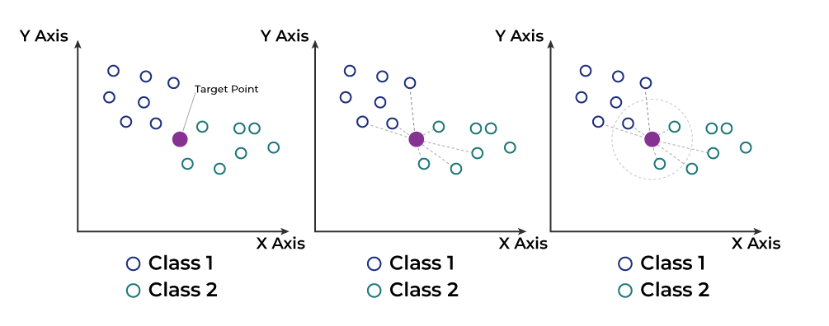
Figure 2 Working of KNN Algorithm (Dadi, 2024)
SVM Algorithm:
The working of the SVM algorithm can be understood by using an example. Suppose that we have a dataset that has two tags (red and blue), and the dataset has two features x1 and x2. We want a classifier that can classify the pair (x1, x2) of coordinates in either red or blue. We can easily separate these two classes. But there can be multiple lines that can separate these classes. Consider the image
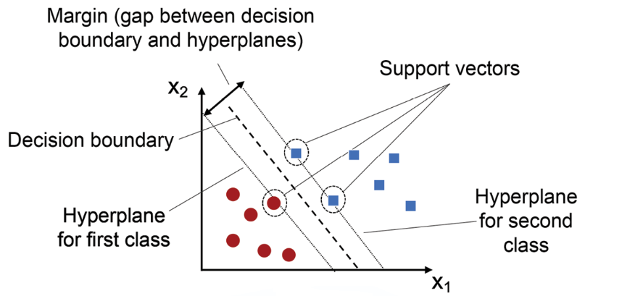
Figure 3 Working of SVM Algorithm (Kumar Ajitesh, 2023)

Hence, the SVM algorithm helps to find the best line or decision boundary; this best boundary or region is called a hyperplane. SVM algorithm finds the closest point of the lines from both classes. These points are called support vectors. The distance between the vectors and the hyperplane is called as margin. And the goal of SVM is to maximize this margin. The hyperplane with maximum margin is called the optimal hyperplane.

Literature Review:
Resume parsing has come a long way, and the use of natural language processing and manginess learning has enhanced the parsing and categorizing of the information. A method uses the Spacy NER model that improves the process of data extraction and the efficiency of which directly depends on the NLP model chosen (Chavare and Patil, 2023) . The paper focuses on BERT for sentence pair classification with 100% accuracy for LinkedIn resume classification and 73% for candidate suitability while the models’ performance declined in other formats (Bhatia et al., 2019). This shows that it is possible to use BERT to set up a starting point for generating the rank in order of how suitable a candidate.
Besides, the high efficiency of resume parsing has been achieved by neural networks and CRF where CNN with different segment classification is used, while Bidirectional LSTM-CNN with CRF is used for sequence labelling. Its strength is in segmentation and entity extraction but for large datasets it may turn to be costly in terms of computation (Ayishathahira, Sreejith and Raseek, 2018). Another noticeable approach applies NLP and deep learning for NER and obtains an identification accuracy of 93% when it is distinct resume formats (Thangaramya et al., 2024).
The e-recruitment framework uses text block classification, NER, and ontology to extract correct information, but this process is time taking because require large annotated data set (Sajid et al., 2022). There is a basic approach that requires using keyword matching and clustering, while it is easy to use, it is quite rigid in terms of different formats of resumes (Sanyal, Hazra and Adhikary, 2017). Consequently, through the multilabel classification processes, the group of neural network models, including BPNN, CNN, BiLSTM, and CRNN, displayed a high level of accuracy in analysing the texts with the notes that the higher accuracy depends on the specifics of the selected model.
The combination of NLP with ATS results in resume parsing and ranking hence giving real-time analysis of the recruitment process, but this integration is done with existing ATS systems (Nisha et al., 2023). The study by (Srivastava and Greaney, 2023) on ‘‘multipartite job domain BERT-based Named Entity Recognition’’ supports the essence of the quantity and quality of data annotated for proper information extraction. Furthermore, when used along with keyword and pattern matching that is achieved by employing Regex, the accuracy of NER is high regardless of format of resume (Sougandh et al., 2023).
It is equally important to note that the multi-level classification technique in the resume segmentation significantly reduces employers’ time but needs a large training dataset (Gunaseelan, Mandal and Rajagopalan, 2020). The process of candidate ranking is based on Machine Learning, and the “Predictive Human Resource Candidate Ranking System” is used for that; Experience and skills are main criteria for candidate selection, but it requires much development time (Bhagyashree Anilkumar Koyande, 2020). Another approach is to predict the job domain by applying NER based on skill sets, which yields acceptable accuracy, although the result strongly depends on the input data (Mittal et al., 2020).
The techniques of text conversion and similarity comparison assist in the consideration of CVs and the matching with job descriptions, but they encounter issues with different types of resume presentations (Sroison, Chan and Jonathan Hoyin Chan, 2017). Online Resume Parsing Resumes into jobs employing Text analysis and sentiment analysis help with an efficient recruitment process but incorporate bias into the assessment of the sentiment (Chandola et al., 2015).
Analysis gap: Existing systems fail to integrate sophisticated Natural Language Processing (NLP) techniques with resumes, such as K-Nearest Neighbours (KNN) and Support Vector Machines (SVM), that lead to optimal accuracy of parsing and classification and therefore enhance the effectiveness and efficiency of recruitment.
Finally, in my project ‘Resume Parser using Streamlit Framework’, I use K-Nearest Neighbours (KNN) and Support Vector Machine (SVM) for classification and prediction to increase performance after applying data pre-processes and feature extraction.
Table 1 shows the analysis of the literature review.
Table 1 Literature Review Analysis
Author(s) | Methodology | Merits | Demerits | Strengths and Limitations | Key Findings
(Chavare and Patil, 2023) | Automated data extraction, parsing, and standardization using Spacy NER model | Improved extraction of relevant information | Dependent on NLP model accuracy | Effective in reducing manual effort and error in résumé parsing | Provides a systematic approach to extract and categorize résumé information
(Bhatia et al., 2019) | BERT sentence pair classification, LinkedIn and non-LinkedIn resumes parsing | 100% accuracy for LinkedIn resumes, 73% accuracy for candidate suitability | Lower accuracy for non-LinkedIn formats | Public web application; strong baseline for suitability ranking | Efficient candidate ranking system for job descriptions
(Ayishathahira, Sreejith and Raseek, 2018) | CNN for segment classification, Bi-LSTM-CNN and CRF for sequence labelling, Glove for word embedding | Efficient segmentation and entity extraction from unstructured resumes | Potential complexity and computational cost | Utilizes advanced deep learning models for accurate parsing; suitable for unstructured documents | Successfully classifies resumes into three segments and extracts 23 fields; demonstrates potential for improved resume parsing in recruitment processes
(Thangaramya et al., 2024) | NLP, Deep Learning for NER | High accuracy (93%), Efficient ranking system | Limited to certain resume formats | Strengths: High accuracy close to human level, saves time and manpower. Limitations: May not handle all resume formats equally. | High accuracy in information extraction (93%), Reliable results, efficiently ranks resumes saving time and manpower.
(Sajid et al., 2022) | Text block classification, NER, Ontology | Accurate information extraction | Requires large amounts of annotated data, Time-intensive | Strengths: Accurate information extraction. Limitations: Dependency on annotated data, time-consuming. | Accurately extracts information from resumes, improving profile matching and applicant ranking.
(Sanyal, Hazra and Adhikary, 2017) | Keyword matching, Clustering | User-friendly, Auto-fills forms for proofreading | Limited flexibility in handling diverse resume formats | Strengths: User-friendly interface, efficient keyword matching. Limitations: Limited flexibility in format handling. | Parses information, auto-fills forms, saves resumes in JSON and PDF formats.
(Satheesh et al., 2020) | NLP, SpaCy NER model | Automates resume screening, Generates score graphs for resumes | May not account for all job-specific nuances | Strengths: Efficient automation, score generation for resumes. Limitations: May miss job-specific nuances. | Automates screening, extracts required entities, generates scores for efficient candidate selection.
(Bhor et al., 2021) | NLP, Text block extraction | Streamlines hiring process, ranks resumes based on skills and requirements | Complex integration with job portals | Strengths: Efficient information extraction, streamlines hiring. Limitations: Complex integration with job portals. | Extracts and ranks resume based on skills and requirements, facilitating efficient hiring.
(Zainul Abideen Mohd Sadiq et al., 2007) | NLP, ML, Social profile analysis | Comprehensive candidate profiles, Integrates social profiles | Privacy concerns with social profile analysis | Strengths: Comprehensive profiles, integrates social profiles. Limitations: Privacy concerns. | Ranks resumes based on constraints, integrates social profiles for comprehensive candidate evaluation.
(Liu et al., 2021) | Neural networks (BPNN, CNN, BiLSTM, CRNN) | High accuracy (96%), Efficient text classification | Varying accuracy across models | Strengths: High accuracy with CRNN, efficient text classification. Limitations: Varying model accuracy. | CRNN achieves 96% accuracy, CNN lowest accuracy, highlights efficiency of neural networks in text classification.
(Nisha et al., 2023) | NLP algorithms, ATS integration | Customizable, Real-time insights, Streamlines recruitment workflow | May require specific ATS integration | Strengths: Customizable, real-time insights, efficient workflow. Limitations: Specific ATS integration requirements. | Enhances recruitment efficiency, customizable to job requirements, provides real-time insights and integrates with ATS.
(Srivastava and Greaney, 2023) | BERT, Transfer learning, Custom NER dataset | Accurate information extraction, Effective across diverse job domains | Dependent on data size and annotation quality | Strengths: Accurate extraction, effective for various domains. Limitations: Data size and annotation quality dependency. | Fine-tuned BERT model extracts relevant information, highlights importance of data quality in NER training.
(Sougandh et al., 2023) | NER model, Keyword and Pattern Matching using Regex | High accuracy and performance, Handles various resume formats | May struggle with non-standard resume layouts | Strengths: High accuracy handles diverse formats. Limitations: Non-standard layouts may pose challenges. | Integrates NER and Regex for precise extraction, performs well even with varied resume formats.
(Gunaseelan, Mandal and Rajagopalan, 2020) | Multi-level classification techniques | State-of-the-art accuracy in segmenting resumes, Saves time for employers | May require extensive training data | Strengths: High accuracy in segmenting, timesaving. Limitations: Needs extensive training data. | Achieves high accuracy in extracting skillsets, experience, and education, effectively maps resumes to job descriptions.
(Bhagyashree Anilkumar Koyande, 2020) | Machine learning, candidate ranking based on experience, key skills, and other aspects | Focuses on multiple aspects, helps in selecting the right candidate | May require extensive setup and training | Comprehensive candidate ranking system, considers multiple important aspects | Ranks candidates based on experience, key skills, and other vital aspects, aids in selecting the right candidate
(Mittal et al., 2020) | Named Entity Recognition (Stanford CoreNLP), skillset-based genre assignment | Converts unstructured data into structured format, high prediction accuracy (91.47%) | Dependent on the quality of skillset data | High prediction accuracy, structured data conversion | Extracts relevant information, assigns resumes to job domains based on skillset, 91.47% prediction accuracy
(Sroison, Chan and Jonathan Hoyin Chan, 2017) | NLP, text conversion, similarity comparison | Handles various resume formats, compares resumes to job descriptions | May face issues with varied resume formats and quality of job descriptions | Converts various formats to text, similarity comparison with job descriptions | Assists in screening resumes, finds the best candidate based on job description similarity
(Chandola et al., 2015) | Text Analytics, Sentiment Analysis | Simplifies hiring process, reduces risk of shortlisting wrong candidates | Sentiment analysis may be subjective | Text Analytics, simplifies the process, reduces errors | Judges resumes based on content, uses sentiment analysis for candidate evaluation
My Project | K-Nearest Neighbors (KNN) and Support Vector Machine (SVM) for classification and prediction | Automated classification, prediction, and recommendation processes | Dependent on data preprocessing and feature extraction accuracy | Efficient classification and prediction with KNN; precise separation with SVM | Enhanced resume parsing accuracy using KNN and SVM; improved classification, prediction, and recommendation processes

Methodology
This research applies a comprehensive methodology that integrates the use of Natural Language Processing and Machine Learning for the development of a sophisticated automated Resume Parsing system. This adopts the Streamlit framework for the development of an interactive web application that allows the recruiter and user to interface with parsed resume data easily.

System Architecture
The architecture of resume parser is shown in Figure 4. The section are as follows:
The project starts with collecting data. First, we collect many real-world resumes samples from company databases or public repositories then we manually label them into categories including job roles, levels of experience and educational level as well. These resumes are used as training data and validation data for building and training machine learning models. The set of resumes will be sent into a database with sensitive information about users being removed to make sure the raw resumes are treated in a secure manner and are safe for further processing.
The second step is preprocessing in which raw resume examples are transformed into a format ready for processing. This category includes a whole set of natural language processing (NLP) techniques such as text extraction, cleaning, tokenisation, and named entity recognition (NER), as well as text classification that will further divide the content of the resumes such as education and work experience.
After preprocessing, textual data is feature extracted and vectorised in the form of numeric features for machine learning models. This step usually involves: TF-IDF (Term Frequency-Inverse Document Frequency): This statistical measure measures the significance of a word in a given document relative to a collection of documents and can highlight key terms. Word Embedding: Word2Vec or GloVe, for example, convert words to vectorised representations that retain semantic meaning in continuous vector space.
The system firstly uses machine learning algorithms to label the resume’s, by two main mechanisms: The K-Nearest Neighbors (KNN) algorithm categorises resumes depending on how similar they are to other resumes in your dataset. This is a very good one for categorising resumes into roles, degrees of education, or particular skill sets. Support Vector Machine (SVM) is used for more advanced classification tasks. It seeks an optimal hyperplane to separate classes in the feature space. Hence the classification performance achieved by SVM is robust.
The Model Training is a human labelled data, including resumes along with information such as academic background, work experience and skills profiles, was used to train machine learning models, so they can generalize when classifying new resumes by learning patterns and features from the dataset.
Subsequently, the models are evaluation on an external validation dataset set aside during the training process; such a dataset is termed an out-of-sample dataset. The models’ performance is then quantified using statistics like Mean Squared Error (MSE), Root Mean Squared Error (RMSE), the Coefficient of Determination (R²), precision, recall and F1-score. This allows us to determine whether the model has sufficiently good generalization to perform well on new data.
Next, we’ll train these models so they can generate predictions for new resumes. When you upload a resume, it follows the above steps – preprocessing and feature extraction – to produce a feature vector, which is passed into either the KNN or SVM model stored inside ‘model. joblib’. The model will predict the job role or classification and may create a corresponding suitability score by comparing to criteria held in a database. These predictions and scores will be stored in a database for later retrieval. HR personnel will log into a dashboard where they can look over all the classified and scored resumes, and filter them via criteria such as job role, or suitability score, to help them find suitable applicants quickly. A workflow that combines data capture, NLP, machine learning and database management may be able to improve the recruitment pipeline.

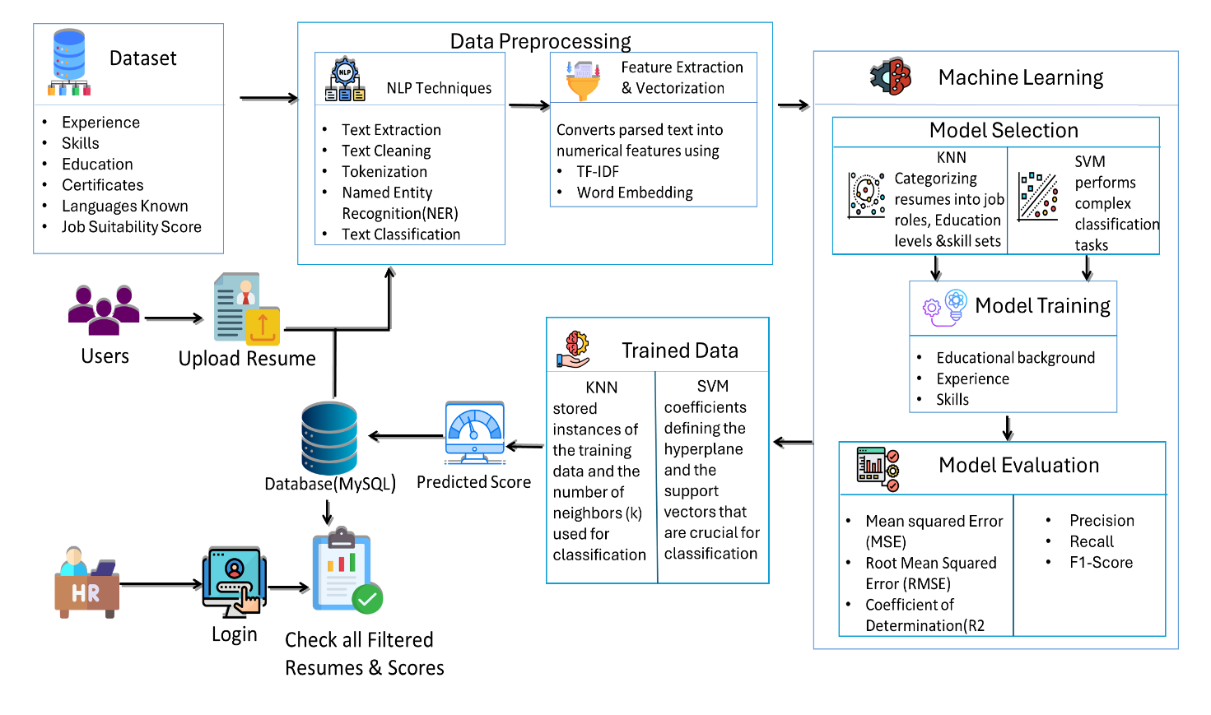
Figure 4 System Architecture for Resume Parser

The system is divided into two primary modules:
Module 1: HR: The HR module uses the resume parser feature to help the HR professional analyse the candidate’s profile in a much easier way, since the system parses the resume. The resume parser gives a score indicating how good the resume fit the job opening. Just based on these scores, the HR will be able to shortlist the candidates easily, and the HR can be sure that only the best candidates are given to the decision makers. In this way, the module supports more informed and effective hiring.
Module 2: User: The user module involves submitting a resume by the user; the system then provides feedback regarding the constructed ontology (and what someone is ‘made up of’), as well as a score reflecting the extent to which the uploaded resume fits a given job requirement, and relevant feedback to the user regarding how their resume ranks relative to others being considered for the position. This feedback would be important to users interested in honing their resume to increase their chances of being a match for a position. With this, the user module allows for better matching of job applications to job requirements.
System Output: The system produces a predicted score for each resume based on the set of computations executed in the machine learning models. HR staff can then use these scores to determine the fittingness of candidates for a role, ultimately helping them overcome any inherent biases they might have and make employment selections in a more objective and data-driven fashion.

Process Flow Diagram – Step-by-Step
The flowchart depicts how the information contained within a resume of a candidate is uploaded, parsed, classified (through NLP and ML techniques), stored and accessed through different modules. This system has been developed to collect and categorise the data to screen millions of resumes. The resume is analysed and classified according to pre-defined keywords and information. A Figure 5 describes a detailed process of storing and ranking resumes using NLP and ML techniques.
At the start of the process, a candidate can upload their resume. This uploaded resume will be first converted using NLP techniques, which are three stages such as named entity recognition (NER), tokenisation and text classification. The NER algorithm identifies and classifies the names, organisation, dates etc from the text. Tokenisation breaks down the text into individual tokens which helps to proceed further stages. The resulted tokens are classified into pre-determinates classes by text classification technique. Implementation code will be shown in Appendix 6.1.1
Next is classification, based on the parsing. For this, the system uses two ML algorithms, namely K-Nearest Neighbours (KNN) and Support Vector Machine (SVM). These algorithms transform the input resumes into feature vectors, i.e., numbers that represent the textual data. The ML models are trained via labelled data to achieve a high degree of accuracy in classifying new resumes. Classification involves inputting the resumes into the trained KNN and SVM models and classifying based on the nearest neighbours and optimal hyperplanes respectively. Implementation code will be shown in Appendix 6.1.2
After classifying, the result will be integrated, and then it is stored in a MySQL database. For the saved results, resumes classify information can be seen by users including the resumes which recruited by HR and the resumes which sent by the candidates. The example code was stored result in database will be shown in Appendix 6.1.3. The system reaches a login page. It has 2 module named HR Module and User Module.
- The HR Module is used by recruited managers for the resumes stored in the database.
- The candidate can use the User Module for uploading resumes and check classification results
The resumes score will be check If the system score is satisfied, it will reach the end of the workflow. By this automatic resume management system, the resume information can be extracted, classified and saved in the database. And this can decrease a lot of human labour and reach a high efficiency

Algorithm Implementation in Pseudocode
BEGIN
# Step 1: Data Collection
CONNECT to Database (MySQL)
# Step 2: Users Upload Resume
UPLOAD Resume by User
# Step 3: Preprocessing & NLP Process
FUNCTION preprocess_resume(resume):
EXTRACT text from resume
CLEAN the text (remove punctuation, stopwords, etc.)
TOKENIZE the text
PERFORM Named Entity Recognition (NER) on text
CLASSIFY text into predefined categories
RETURN processed_text
processed_text = preprocess_resume(uploaded_resume)
# Step 4: Feature Extraction & Vectorization
FUNCTION extract_features(processed_text):
CONVERT text to numerical features using TF-IDF
PERFORM Word Embedding on text
RETURN features
features = extract_features(processed_text)
# Step 5: Machine Learning Classification
FUNCTION classify_resume(features):
# K-Nearest Neighbors for categorizing resumes
APPLY KNN to categorize resumes into job roles, education levels, and skill sets
# Support Vector Machine for complex classification tasks
APPLY SVM for further classification
RETURN classification_result
classification_result = classify_resume(features)
# Step 6: Model Training
FUNCTION train_model(data):
TRAIN model using educational background, experience, and skills
RETURN trained_model
trained_model = train_model(training_data)
# Step 7: Predicting Score
FUNCTION predict_score (trained_model, classification_result):
PREDICT score based on classification result using the trained model
RETURN predicted_score
predicted_score = predict_score (trained_model, classification_result)
# Step 8: Store results in Database
STORE processed_text, classification_result, and predicted_score in Database
# Step 9: HR Login and Review
FUNCTION hr_review ():
LOGIN HR
FETCH all filtered resumes and scores from Database
DISPLAY resumes and scores for HR review
hr_review ()
END

Algorithm for Resume Classification Flowchart:
- Data Collection
Data Sources: The dataset is obtained from Kaggle, it is consisting of 10000 data, the data are consisting of various fields like, Educational Background, Experience, Certification, Language Known, Job Suitability Score and Skills. The dataset contains some important columns, which describes the details of the candidate. The example code was data collection shown in Appendix 6.1.1. The 'Experience' column gives the number of years a candidate is working. 'Skills' column tells us the skills candidates have. The 'Education' column gives us the highest education a candidate got. The columns 'Certifications' lists the certifications a candidate has. The 'Languages Known' column tells the languages a candidate knows. The column 'Job Suitability Score' is a number which shows how suitable a candidate is for a job. It means how much qualitative score a candidate will get. Here’s the summary of data,
- Experience: Ranges from 1 to 20 years.
- Skills: 10 unique skill sets.
- Education: 7 unique educational backgrounds.
- Certifications: 7 unique certifications.
- Languages Known: 7 unique combinations of languages.
- Job Suitability Score: Ranges from 1 to 100, with a mean of 50.29 and a standard deviation of 28.87.

- User Upload Resume:
The user inputs their resume through the User Module, which can understand users' inputs and accepts attachments of resumes in any format. Implementation code shown in Appendix 6.1.2
- Preprocessing & NLP Process
However, there are several fundamental ‘preprocessing’ steps that need to be performed on the data before the NLP techniques can be successfully applied. The process of cleaning the data (known as data preprocessing) is crucial, because many real-world text datasets contain inconsistencies and noise that can adversely affect the performance of the NLP models. The Implementation code for all these processes shown in Appendix 6.1.3
Next, the text gets cleaned. This usually involves all punctuation marks, numbers and so-called stop words removed – those words that do not carry much meaning in a text, such as ‘and’, ‘the’ or ‘is. The text is also turned to lowercase to keep it consistent and avoid complexity.
Once the text is cleaned, the data will be tokenised. Tokenisation is an important step where the text will be split into different tokens. Token is a word or an expression, or sometimes a symbol. For instance, regarding the parsing of resumes, while the text of a resume will be tokenised and will be separated into words or key phrases, they are then available for analysis separately.
Following tokenisation, the text is often further processed with steps such as stemming and lemmatisation. Stemming, for example, involves reducing word forms to their stem. For example, ‘up’, ‘ups’, and ‘upping’ would be stemmed too ‘up’. Lemmatisation goes one step further than stemming, while also addressing its inherent limitations: it reduces each word to its dictionary form or base (or, in other words, lemma). For example, ‘up’, ‘ups’, ‘upping’, ‘upped’, ‘upwards’, and ‘uplifting’ would all be lemmatised too ‘up’. This heuristic normalises the text by alleviating the need to identify variants of a word during analysis.
The next step is the application of specific NLP techniques, such as Named Entity Recognition (NER). NER allows to identify and categorise specific entities in the text: names of people, organisations or locations. For example, we can use NER to identify and categorise names of candidates, educational institutions or previous employers in a resume.
Other core NLP task is text classification, which seeks to assign text to predefined classes based on its content. This is important in resume parsing, where ‘education’, ‘experience’ and ‘skills’ sections of resumes are key data to be processed separately.
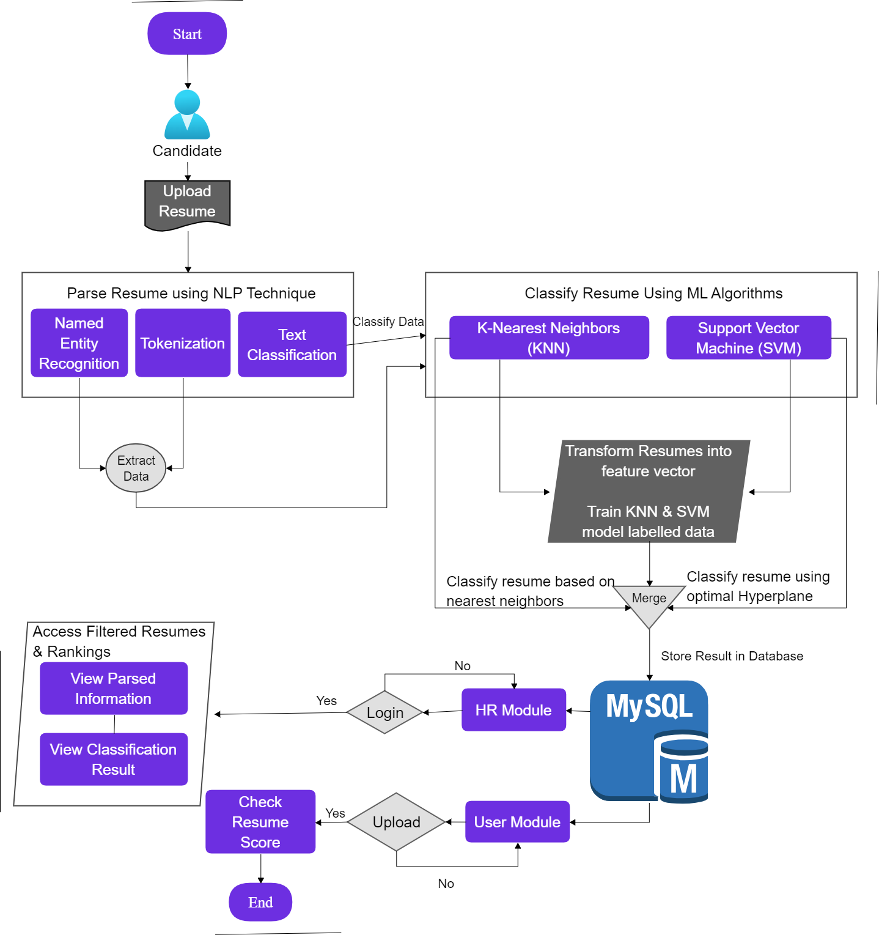
Figure 5 Resume Parser and Classification System

- Feature Extraction & Vectorization
At the second stage of feature extraction and vectorisation, the processed text is represented as numerical features using two main methods:
First, Term Frequency-Inverse Document Frequency (TF-IDF), which convert textual data into numerical features, by scoring the relevance of each word in a document relative to the corpus. The TF-IDF method scores unique words in individual documents as well as important words across the corpus as high.
Second, Word Embedding, which Words may be embedded in a vector space (a specific type of multidimensional geometry), that is, represented by a set of numbers in a continuous space. This means that each word is represented by a specific point in this space (a vector). The most common example of this is the Word2Vec or GloVe method of building word embeddings by making the space reflect the semantic relationships between words. This allows the model to grasp contextual similarities and differences. The example code shown in Appendix 6.1.4.
- Machine Learning Classification
The core of the methodology involves the selection and training of machine learning models. The aim of this step is to identify the job role, level of education, or skill set of individuals based on their resumes. Here is how it works:
Algorithm Selection:
K-Nearest Neighbours (KNN) algorithm is used for clustering resumes. It defines the category of a new resume based on its similarity to other resumes in the dataset. For example, it can cluster resumes by job role, education level, or even by a specific skill set. Based on ‘k’ (where ‘k’ is typically not very large) most similar (nearest) resumes in the dataset, it defines the category of a new job applicant by the fact that most of its k nearest neighbours also belong to the same category.
Support Vector Machine (SVM: is a classifier for harder tasks. SVM finds the hyperplane that best separates the classes in feature space where objects are defined by their measurable properties. With this separation at hand, the system can make more fine-grained classifications, especially if the classes themselves are not very clear-cut.
Feature Input: The feature vectors extracted in the preceding step (feature extraction) are then plugged into the KNN and SVM algorithms. These feature vectors are numerical representations of the resumes that retain the textual data necessary for classification.
Classification Process:
The KNN algorithm determines a class for a given resume by measuring its feature vector against feature vectors seen in the training set. The resume is then categorised according to the majority class of its K nearest neighbors.
The SVM algorithm is first applied to the feature vectors, and the classes (job roles) are discerned based on the decision boundary (hyperplane) that most efficiently separates the classes of resumes.
Integration of Results: KNN and SVM classifications are generated respectively and then these two results are combined to make the final classification decision about how to put the resume into the system.
Storing Classification Results: All the classification decisions are stored in the system database for further analysis and retrieval. The community module uses this data for hiring decisions and user module reports back to the candidates.
The code implementation of machine learning classification is shown in Appendix 6.1.5.
- Model Training
This involves training the models on 80% of the data while 20% is used for testing. As such, the strategies enable cross-validation to ensure no overfitting by models and parameter tuning, for example, the number of neighbors in KNN and kernel type in SVM. In feature extraction processes, representations of textual data are transformed into corresponding numeric formats that can be utilized within the algorithmic computations using TF-IDF and word embeddings. The example code was Appendix 6.1.6

- Predicting Score
In the scoring step, the system uses the trained model to predict a score for each resume for the given classification problem, with the score representing the affinity of the resume to the given label (possibly, a job title, occupation or set of skills). Refer Appendix 6.1.7 for code implementation part of predict the score.
- Store Result in Database
Results of the processing, classification and scores are stored back in the MySQL database so that all the data can be accessed later. Refer Appendix 6.1.8
- HR Login and Review
After that, login with HR clerk or users access system, view the parsed information and the classification results, as well as the resume score. Meanwhile, if don’t login yet, just upload resume. The process ended when people viewed the results, so that it takes an efficient way for resume classification and rank. The implementation code as shown in Appendix 6.1.9

Result & Analysis
This is a comprehensive evaluation of the resume parsing and classification system ran under Streamlit framework. I will showcase various metrics between the different solutions and present one by one the performance of each machine learning algorithm: K-Nearest Neighbors (KNN) and Support Vector Machines (SVM). Efficiency is analysed to meticulously evaluate if the system can accurately parse and categorize resume data.

Deployment

Resource Requirements:
The project's resource requirements are defined as follows:
Software Requirements:
- Operating System: Windows 7 or later
- Simulation Tool: Visual Studio Code
- Database: MySQL
- Back-End: Python
Hardware Requirements:
- CPU Type: Intel i5 or above
- RAM Size: 4GB
- Hard Disk Capacity: 80 GB

Deployment Environment:
It is also possible to have a single-machine setup for local deployment. In this case, the system can operate independently on one machine, which is convenient for development, testing or custom use cases where the user base is only one person or a very small group.
- Local server: the app runs on a local server; e.g. you can open http://localhost:8501 or another port on your browser and hit the button or link, and work in it on the local machine.
- Local setup: ability to handle NLP processing and machine-learning model inference, want to say a laptop, if this is scaled up could consider fitting this to a desktop but currently this portion of the local setup could handle on a laptop, depends on the number of rows and how complex the models

Development Process
Requirement Analysis phase provides the core features and capabilities functionalities that the resume parsing system must possess to provide the solution to the problem. The requirement of the resume parsing system specifies the business functions for the system that gives functionalities to the user that captures the data from the resumes in a human sounding document. The functionality of the system can be capture in the requirement analysis phase that includes the customer needs, feasibility study, negotiation, solution definition, specification of requirements, validate specifications and manage requirement during the development lifecycle.
Python is chosen as a main language of implementation due to its dynamic, high-level nature and support for both object-oriented and procedural programming. It also serves as the best choice, considering its ease of use, free and open-source availability, and broad community coverage. Python is an interpreted language, cross-platform, and easily portable to different operating systems such as Windows, macOS, and other UNIX-based systems. These are the main reasons why Python is chosen for this resume parsing system.
Python has several features that are important for creating a user-friendly application. First, it is a highly readable language; second, it is plain and simple; third, it is extendable, meaning that one can combine different blocks of codes to create a new one; and finally, it has a good support for GUI programming.
Anaconda The project’s dependences are managed with the Anaconda distribution, which comes with more than 250 pre-installed packages, as well as the ability to install additional packages from the PyPI or Anaconda platform. Given that data science projects usually require many packages, Anaconda is well-suited to work with such projects. Due to the management of package dependencies, Anaconda takes care of the consistency of package versions and avoids the conflict that results from different packages having dependencies on different versions of the same package. When working on projects in teams, Anaconda’s environment management facility also allows users to create isolated environments where different software versions can be tested or deployed.
Anaconda Navigator is a graphical user interface (GUI) for managing packages, environments, repositories and channels of the Anaconda environment. This tool is useful for novices because it eases the process of package management, instead of using command-line commands. Furthermore, it can be used with different packages including JupyterLab, Jupyter Notebook, Spyder and Visual Studio Code, to reduce the time needed to develop and analyse data.
Jupyter Notebook is selected as a development and analysis tool of choice due to its interactive, web-based interface. Jupyter Notebooks provide a flexible format that allows for integration of code, text, mathematics, plots and multimedia in one document. They provide strong support for exploratory data analysis and documentation. A Jupyter Notebook using the IPython kernel. The integration of code and the ability to test various data and algorithm versions in real time allow for a more iterative process of development.

Libraries and Their Roles
Our resume parser application uses a lot of libraries that help with the processing, analysis, and acquisition of data. Libraries are created for some specific purposes that add up to the complete functionality of a project. Here is a brief description of the major libraries we used:
Streamlit (import streamlit as st): Streamlit library creates amazing web applications for data science and machine learning projects. It is built to make it easier and faster than ever to create web apps with data-driven functionality and the fewest lines of code. We are also using Streamlit to initiate a server that interacts with our beam-serve jobs for users to communicate through with the Web UI used for the resume parser.
Pandas (import pandas as pd): Pandas is an open-source, BSD-licensed library providing high-performance, easy-to-use data structures, and data analysis tools for the Python programming language. It can also be utilized in data extraction, apart from the resume processing and analytics that our project brings about.
PyMySQL (connect to a MySQL database): PyMySQL is the library you can use to connect and interact with MySQL databases from Python. This package allows the execution of SQL queries and fetching data from MySQL databases. Here it is used for database interaction to save resume data and fetch the same.
Plotly (import plotly. from plotly Readable import px): Here I am making use of the Plotly package for interactive visualizations! And the complete snippet is shown below (Using "plotly. graph_objects" as go): Plotly also provides a high-level interface for working with everyday plots, as does this library. It provides more powerful graph objects using which one can create multiple levels of graphs. They are probably used in the admin session to view data from importing resumes.
Geopy (from geopy. We are going to use Geopy (import geocoders from Nominatim): A library for accessing and decoding locale data. Nominatim is a geocoder - which converts locations such as city or street names to latitude and longitude. We, in our project, can use it to extract the location information from resumes - for sure!
PyResparser (from pyresparser import ResumeParser): PyResparser is a resume parsing library only capable of fetching data such as names, skills, and experience from resumes. It is the base library used for resume file analysis and data extraction.
PDFMiner (from pdfminer3.layout import LAParams, LTTextBox other imports about this library if they are present on the system): PDFMiner is a library that extracts information from text and image watermarks in hardcopy or softcopy documents either manually or scanned. It can also be used to parse resumes of applicants belonging to different fields, but it extracts only texts using this library. It does this by reading the layout and text content of PDFs.
Python Imaging Library (Pillow): Pillow is an image processing library that can be used to open, manipulate, and save image files. For example, in the project at hand, it could be applied to manage images present in the resumes or any other kind of image processing.
Joblib (import joblib): It is meant to handle the serialization and deserialization of Python objects, particularly those related to pickling in ML models. It appears most likely to be used to orchestrate pre-trained models for predicting and analyzing resume data.
NLTK (import nltk): NLTK - the Natural Language Toolkit - for processing human language data, provides easy no-barrier access to high-quality language corpora and other lexical resources like Stop words elimination. It is used in our project to preprocess and analyse text that we extract from resumes.

Results Analysis
The result analysis part is an in-depth exploration of the outcomes of the resume parser project using Streamlit, which will compare multiple metrics and show the performance of different machine learning algorithms, as well as the efficiency and accuracy of the system.

Evaluation Metrics for Regression Models
Regression metrics are quantitative measures used to evaluate the nice of a regression model. Scikit-analyse provides several metrics, each with its own strengths and boundaries, to assess how well a model suits the statistics. Table 2 is shown as evaluate regression models, we often use metrics like Mean Absolute Error (MAE), Root Mean Square Error (RMSE), and the Coefficient of Determination (R²). These metrics help in understanding the performance of the model in terms of how well it predicts the target variable.
- MAE: It measures, for a set of predictions, the average magnitude of the errors (without regard to their signs) by averaging over the test sample the absolute differences between prediction and observation, with equal weight for each single difference.(Willmott and Matsuura, 2005)
$$MAE= \frac{1}{n} \sum_{i=1}^{n}{\left|y_{i}- \hat{y_{i}} \right|}$$
where $y_{i}$ is the actual value and $\hat{y_{i}}$ is the predicted value.
- RMSE is the square root of the average of squared differences between the predicted and actual values. (Chai and Draxler, 2014)
$$RMSE=\sqrt{\frac{1}{n} \sum_{i=1}^{n}{{\left(y_{i}- \hat{y_{i}} \right)}^{2}}}$$

- Coefficient of Determination (R²): Measures the proportion of the variance in the dependent variable that is predictable from the independent variables. R² always ranges from 0 to 1, with larger values indicating better accuracy of prediction. (Draper and Smith, 1998)
$$R^{2}=1-\frac{\sum_{i=1}^{n}{{\left(y_{i}- \hat{y_{i}} \right)}^{2}}}{\sum_{i=1}^{n}{{\left(y_{i}- \overline{y} \right)}^{2}}}$$
where $\overline{y}$ ​ is the mean of the actual values.

The following graph illustrates the Mean Absolute Error (MAE), Root Mean Square Error (RMSE), and Coefficient of Determination (R²) for the KNN and SVM models across different resume sections:
Mean Absolute Error (MAE) Comparison: The MAE model shows that the SVM model has consistently lower error rates than the KNN model in all categories. This means that SVM is very good at predicting results that are close to the actual values.
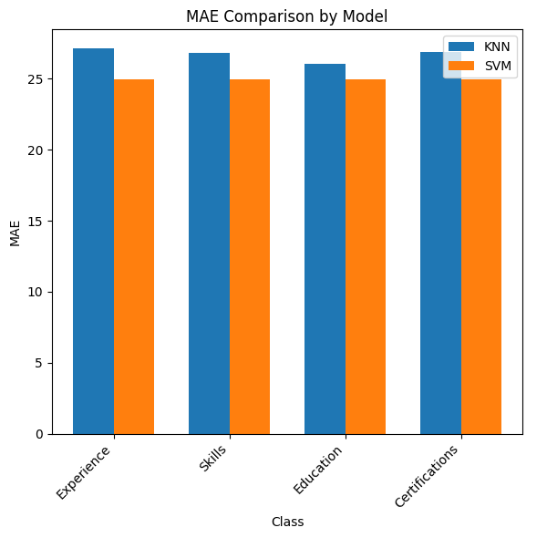
Figure 6 Mean Absolute Error Comparison by Model
Root Mean Square Error (RMSE) Comparison: The RMSE chart also shows that SVM performs better than KNN for all classes, which means that SVM has lower prediction error, especially when it comes to large errors.

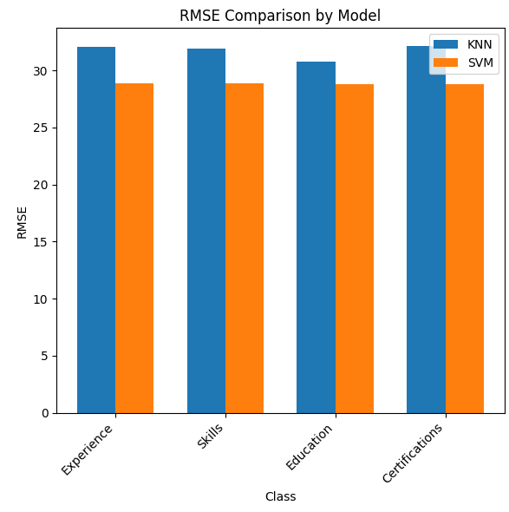
Figure 7 Root Mean Square Error Comparison by Model
R-squared (R2) comparison: The R2 chart shows a clear difference between the two models. The R2 values ​​of the SVM are close to zero for all classes, while the values ​​of the KNN are negative, indicating that the KNN is not so good at explaining the variance in the data.

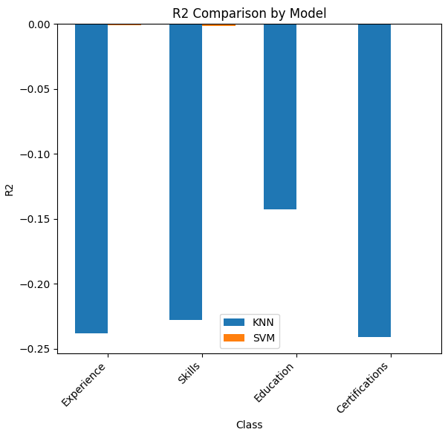
Figure 8 R2 Comparison by Model

Performance Analysis: The following table summarizes the evaluation metrics for the KNN and SVM models across different resume sections:
Table 2 Evaluation metrics for Regression model
Class | Model | MAE | RMSE | R²
Experience | KNN | 27.1148 | 32.0661 | -0.2379
Experience | SVM | 24.9717 | 28.8359 | -0.0011
Skills | KNN | 26.8466 | 31.9365 | -0.2279
Skills | SVM | 24.9702027 | 28.8427 | -0.0015
Education | KNN | 26.0505 | 30.8104 | -0.1429
Education | SVM | 24.9605022 | 28.8232 | -0.0002
Certifications | KNN | 26.8952 | 32.1094 | -0.2413
Certifications | SVM | 24.9507983 | 28.8288 | -0.0006

Interpretation of Results
We can see from the analysis that SVM model consistently outperforms the KNN model across all resume sections, as the MAE and RMSE values are lower, and R2 values are higher (or less negative) in SVM. This indicates SVM has better predictive accuracy for parsing and categorizing of the resumes.
- MAE: The lower MAE values (2.57 vs 3.52) for the SVM model indicate that it predicts the values more accurately than the KNN model.
- RMSE: In same manner the RMSE values of the SVM model are lower which indicates that the SVM model is highly immune to large errors.
- R2: The near-zero R2 values for the SVM model display that while there could be room for improvement with the model, it is accounting for a large portion of the variability in the resume data.
Benefits for the User
- Skill gap: there is a predictive modelling approach where the dependent variable (e.g., ‘job suitability’ or ‘potential performance’ etc) is a numerical score. Candidates can then be directed to the areas where they could improve (e.g., ‘out of 100’).
- Salary estimation: By fitting a linear regression model, you might estimate the salary range to be expected based on experience, education, and skills, helping you better prepare a salary range in mind to negotiate when presented with a job offer.
- Performance Prediction: Individuals can learn how they are likely to perform in a role based on past data, and then decide whether they want to pursue that job.
Benefits of HR
- Performance Prediction: regression models can estimate a candidate’s future performance based on past data and help HR pinpoint high potentials.
- Compensation Planning: Regression models allow HR to predict reasonable pay ranges in advance, therefore making sure that the salary offers are both competitive and in line with the marketplace and the candidate expectations.
- Attrition Risk Assessment: Regression analysis can predict turnover likelihood given satisfaction, engagement scores and other metrics, which allows for proactive retention strategies.
- Resource Allocation: Using regression models, time to full productivity can be estimated so that HR can plan onboarding and training programmes accordingly.

Evaluation Metrics for Classification model
A classification problem is used to identify specific categories of new observations based on one or more independent variables. Also, in this article, we will focus on classification.
- Objective: To evaluate the performance of KNN and SVM models on various features (Experience, Skills, Education, Certifications, Languages Known) in predicting job suitability.
- Methodology: The job suitability score is discretized into three classes: Low, Medium, High (Table 3). TF-IDF is used for text features, and models are trained and evaluated using Accuracy, Precision, Recall, and F1-Score (Table 4).
Table 3 Discretization
Job Suitability Class | Count
Low | 3436
Medium | 3311
High | 3253

The following graphs illustrate the Accuracy, Precision, Recall, and F1-Score for the KNN and SVM models across different feature classes:
Accuracy Comparison: The performance of models has made their way to the end game solving similar classes respectively with just few accuracies percentage deviation. KNN outperforms SVM at most classes on a regular basis.
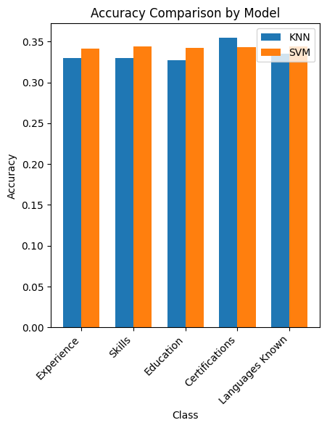
Figure 9 Accuracy Value

Precision Comparison: Very Clearly, across all the precision indicates us that here we have a much higher emphasis on selection of classes, and especially if I compare it with attributes like “Skills” or very specific columns where one input gets classified into many outputs. But in Experience, SVM is better than all
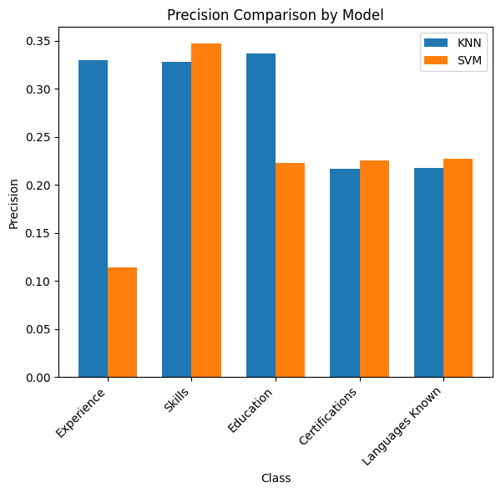
Figure 10 Precision Value

Recall Comparison: The recall scores are very close to each other between the two models, KNN outperforms slightly on most of the classes meaning that it is a little better in predicting true positives among different subjects.
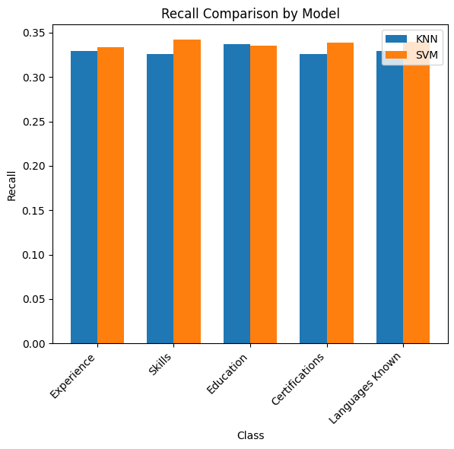
Figure 11 Recall Values

F1-Score Comparison: F1-score balances Precision and Recall KNN dominates across most of the categories, with significant lead in "Skills" and "Certifications". It has not the highest straining time, yet SVM F1-Score is constructed for "Experience" like most of nodes in training stage.
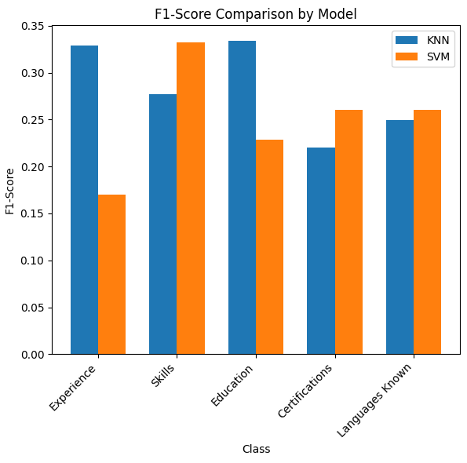
Figure 12 F1-Score Values
Performance Analysis: Here is a detailed table showing the evaluation metrics for both KNN and SVM models across different feature classes:
Table 4 Evaluation metrics for Classification model
Class | Model | Accuracy | Precision | Recall | F1-Score
Experience | KNN | 0.3295 | 0.32946142 | 0.32962972 | 0.32923693
Experience | SVM | 0.3415 | 0.11383333 | 0.33333333 | 0.169710523
Skills | KNN | 0.3295 | 0.32864987 | 0.32965854 | 0.318479007
Skills | SVM | 0.344 | 0.34671519 | 0.34203897 | 0.332146434
Education | KNN | 0.327 | 0.32260932 | 0.32945901 | 0.309585186
Education | SVM | 0.342 | 0.22285463 | 0.3355403 | 0.228391057
Certifications | KNN | 0.3545 | 0.34491884 | 0.35286065 | 0.333305368
Certifications | SVM | 0.3435 | 0.22562193 | 0.33901305 | 0.260516144
Languages Known | KNN | 0.3355 | 0.33775943 | 0.3358235 | 0.333455815
Languages Known | SVM | 0.3445 | 0.22693308 | 0.33987326 | 0.260029251

Interpretation of Results: The analysis indicated that the performance of the KNN and SVM model varies across the resume section. The summary of the outcome is as below:
- Experience: KNN: It shows superior accuracy than SVM in terms of Precision score (0.3295 vs. 0.1138) and F1-Score (0.3292 vs. 0.1697). SVM: Better Recall (0.3333 vs 0.3296) – more likely to identify all relevant cases but at the cost of precision.
- Skills: KNN: Precision and Recall values are close, with a moderate F1-Score of 0.2773.
sitting is the worst posture for back health. SVM: Wins in Precision (0.3467 vs. 0.3281) and F1-Score (0.3321 vs. 0.2773) and is better suited for classification of skills.
- Education: KNN: Better Precision (0.3367 vs. 0.2229) and F1-Score (0.3338 vs. 0.2284) compared to SVM. SVM: Higher Recall (0.3355 vs. 0.3368) than MLP: SVM captures more relevant instances but sacrifices precision.
- Certifications: KNN: Shows moderate performance with Precision (0.2165) and F1-Score (0.2201).
SVM: a bit better on Recall (0.3390) and a better F1-Score (0.2605) than our starting point, which means not tending to prefer true instances vs. instances with a high number of spam emails.
- Languages Known: KNN: Similar performance to Certifications, with moderate values in Precision (0.2173) and F1-Score (0.2498). SVM: Higher recall (0.3399) and higher F1-Score (0.2600) so catching relevant instances more.
Benefits for the User
- Candidate-Specific Feedback: Closely related to the above, but even more specific, each candidate can receive a feedback note tailored to their classification outcome: ‘You’re a good cultural fit for this job’, ‘You’re somewhat of a good cultural fit for this job’, ‘You’re not a good cultural fit for this job’; it might even be useful to elaborate further on the points where the candidate is judged to be a poor fit in more detail.
- Career guidance: candidates can be directed to suitable roles in accordance with their skills, experience or education, you would avoid them applying to positions they are not qualified for.
- Transparency: Knowing the criteria by which they are classified (e.g., skill match, cultural fit) can provide transparency in the recruitment process, leading to higher trust and satisfaction
Benefits for HR
- Efficient Screening: Such models can also be used to automatically classify candidates into different levels of suitability, speeding up the initial screening process and reducing manual effort.
- Improving Hiring Decision: If HR can divide candidates into groups (e.g., those who have experience versus those who don’t, those who have skills versus those who don’t, those who are culturally a good fit for the company versus those who aren’t), it can organise hiring in a much more data-driven way so that it makes good decisions and avoids bias and other problems.
- Targeted Recruitment: HR can utilise classification results to direct recruitment efforts more accurately toward candidate types or jobs

Bibliography
Ayishathahira, C.H., Sreejith, C. and Raseek, C. (2018) ‘Combination of Neural Networks and Conditional Random Fields for Efficient Resume Parsing’, in 2018 International CET Conference on Control, Communication, and Computing (IC4). IEEE, pp. 388–393. Available at: https://doi.org/10.1109/CETIC4.2018.8530883.

Bhagyashree Anilkumar Koyande, R.S.W., M.G.J., D.S. (2020) ‘Predictive Human Resource Candidate Ranking System’, International Journal of Research in Engineering, Science and Management , 3(1), pp. 1–4.

Bhatia, V. et al. (2019) ‘End-to-End Resume Parsing and Finding Candidates for a Job Description using BERT’, Cornell University [Preprint]. Available at: http://arxiv.org/abs/1910.03089.

Bhor, S. et al. (2021) ‘Resume Parser Using Natural Language Processing Techniques’, International Journal of Research in Engineering and Science (IJRES), 9(6), pp. 1–6.

Chai, T. and Draxler, R.R. (2014) ‘Root mean square error (RMSE) or mean absolute error (MAE)? – Arguments against avoiding RMSE in the literature’, Geoscientific Model Development, 7(3), pp. 1247–1250. Available at: https://doi.org/10.5194/gmd-7-1247-2014.

Chandola, D. et al. (2015) ‘ONLINE RESUME PARSING SYSTEM USING TEXT ANALYTICS’, Journal of Multi Disciplinary Engineering Technologies (JMDET), 9(1), pp. 1–5. Available at: www.jmdet.com.

Chavare, D.S. and Patil, A.B. (2023) ‘Resume Parsing using Natural Language Processing.’, Grenze International Journal of Engineering & Technology (GIJET), pp. 721–726. Available at: https://openurl.ebsco.com/EPDB%3Agcd%3A5%3A26366197/detailv2?sid=ebsco%3Aplink%3Acrawler&id=ebsco%3Agcd%3A162319927.

Dadi, B. (2024) Unveiling the Power of K-Nearest Neighbors (KNN) Algorithm: A Brief Guide, Medium. Available at: https://medium.com/@dbhanu520741/unveiling-the-power-of-k-nearest-neighbors-knn-algorithm-a-brief-guide-6d6042caf5fe.

Draper, N.R. and Smith, H. (1998) ‘Selecting the “Best” Regression Equation’, in, pp. 327–368. Available at: https://doi.org/10.1002/9781118625590.ch15.

Gunaseelan, B., Mandal, S. and Rajagopalan, V. (2020) ‘Automatic Extraction of Segments from Resumes using Machine Learning’, in 2020 IEEE 17th India Council International Conference, INDICON 2020. Institute of Electrical and Electronics Engineers Inc. Available at: https://doi.org/10.1109/INDICON49873.2020.9342596.

Kumar Ajitesh (2023) Support Vector Machine (SVM) Python Example, Analytics Yogi. Available at: https://vitalflux.com/wp-content/uploads/2022/08/support-vector-machine-1.png.

Liu, J. et al. (2021) ‘Resume Parsing based on Multi-label Classification using Neural Network models’, in 2021 6th International Conference on Big Data and Computing. New York, NY, USA: ACM, pp. 177–185. Available at: https://doi.org/10.1145/3469968.3469998.

Mittal, V. et al. (2020) ‘Methodology for resume parsing and job domain prediction’, Journal of Statistics and Management Systems, 23(7), pp. 1265–1274. Available at: https://doi.org/10.1080/09720510.2020.1799583.

Nisha, B. et al. (2023) ‘HR Tech Analyst: Automated Resume Parsing and Ranking System through Natural Language Processing’, in 2nd International Conference on Automation, Computing and Renewable Systems, ICACRS 2023 - Proceedings. Institute of Electrical and Electronics Engineers Inc., pp. 1681–1686. Available at: https://doi.org/10.1109/ICACRS58579.2023.10404426.

Sajid, H. et al. (2022) ‘Resume Parsing Framework for E-recruitment’, in Proceedings of the 2022 16th International Conference on Ubiquitous Information Management and Communication, IMCOM 2022. Institute of Electrical and Electronics Engineers Inc. Available at: https://doi.org/10.1109/IMCOM53663.2022.9721762.

Sanyal, S., Hazra, S. and Adhikary, S. (2017) ‘Resume Parser with Natural Language Processing’, International Journal of Research in Engineering and Science (IJRES), 9(6), pp. 1–6. Available at: https://doi.org/10.13140/RG.2.2.11709.05607.

Satheesh, K. et al. (2020) ‘Resume Ranking based on Job Description using SpaCy NER model’, International Research Journal of Engineering and Technology [Preprint]. Available at: www.irjet.net.

Siva Jyothi, P.N. (2023) False Data Recognition employed by logistic regression and NLP Techniques, Mukt Shabd Journal. Available at: https://www.researchgate.net/publication/375914801_False_Data_Recognition_employed_by_logistic_regression_and_NLP_Techniques (Accessed: 24 July 2024).

Sougandh, T.G. et al. (2023) ‘Automated Resume Parsing: A Natural Language Processing Approach’, in 7th IEEE International Conference on Computational Systems and Information Technology for Sustainable Solutions, CSITSS 2023 - Proceedings. Institute of Electrical and Electronics Engineers Inc. Available at: https://doi.org/10.1109/CSITSS60515.2023.10334236.

Srivastava, M. and Greaney, P. (2023) ‘Resume Parsing Across Multiple Job Domains Using a BERT-Based NER Model’, in 2023 31st Irish Conference on Artificial Intelligence and Cognitive Science, AICS 2023. Institute of Electrical and Electronics Engineers Inc. Available at: https://doi.org/10.1109/AICS60730.2023.10470917.

Sroison, P., Chan, J.H. and Jonathan Hoyin Chan, A. (2017) ‘Resume Parser with Natural Language Processing’, International Journal of Research in Engineering and Science (IJRES), 9(6), pp. 1–6. Available at: https://doi.org/10.36227/techrxiv.17641604.v1.

Thangaramya, K. et al. (2024) ‘Automated Resume Parsing and Ranking using Natural Language Processing’, in 2024 3rd International Conference on Artificial Intelligence for Internet of Things, AIIoT 2024. Institute of Electrical and Electronics Engineers Inc. Available at: https://doi.org/10.1109/AIIoT58432.2024.10574696.

Willmott, C. and Matsuura, K. (2005) ‘Advantages of the mean absolute error (MAE) over the root mean square error (RMSE) in assessing average model performance’, Climate Research, 30, pp. 79–82. Available at: https://doi.org/10.3354/cr030079.

Zainul Abideen Mohd Sadiq, S. et al. (2007) ‘Intelligent Hiring with Resume Parser and Ranking using Natural Language Processing and Machine Learning’, International Journal of Innovative Research in Computer and Communication Engineering (An ISO, 3297. Available at: https://doi.org/10.15680/IJIRCCE.2016.

Appendix

Process Flow Diagram Code Implementation

Data Collection
36| import pandas as pd
37| ​
38| dataset_path = '/content/sample_data/dataset.csv'
39| df = pd.read_csv(dataset_path)
40| df.head()

User Upload Resume
239| st.markdown('''<h5 style='text-align: left; color: #021659;'> Upload Your Resume, And Get Smart Recommendations</h5>''',unsafe_allow_html=True)
240|
241| ## file upload in pdf format
242| pdf_file = st.file_uploader("Choose your Resume", type=["pdf"])
243| if pdf_file is not None:
244| with st.spinner('Hang on While We Cook Magic for You...'):
245| time.sleep(4)
246|
247| ### saving the uploaded resume to folder
248| save_image_path = './Uploaded_Resumes/'+pdf_file.name
249| pdf_name = pdf_file.name
250| with open(save_image_path, "wb") as f:
251| f.write(pdf_file.getbuffer())
252| show_pdf(save_image_path)
253| ​

Preprocessing & NLP Process
Preprocessing Data
20| from sklearn.model_selection import train_test_split
21| from sklearn.preprocessing import StandardScaler
22| ​
23| # Standardize the combined features
24| scaler = StandardScaler()
25| X_combined_scaled = scaler.fit_transform(X_combined)
26| ​
27| # Split the data into training and testing sets
28| X_train, X_test, y_train, y_test = train_test_split(X_combined_scaled, y, test_size=0.2, random_state=42)
31| ​
Name Entity recognition (NER):
21| nlp = spacy.load('en_core_web_sm')
22| custom_nlp = spacy.load(os.path.dirname(os.path.abspath(__file__)))
23| self.__ skills_file = skills_file
24| self.__ custom_regex = custom_regex
25| self.__ matcher = Matcher(nlp.vocab)
26| self.__ resume = resume
27| if not isinstance(self.__ resume, io.BytesIO):
28| ext = os.path.splitext(self.__ resume)[1].split('.')[1]
29| else:
30| ext = self.__ resume.name.split('.')[1]
31| self.__ text_raw = utils.extract_text(self.__ resume, '.' + ext)
32| self.__ text = ' '.join(self.__ text_raw.split())
33| self.__ nlp = nlp(self.__ text)
34| self.__ custom_nlp = custom_nlp(self.__text_raw)
35| self.__ noun_chunks = list(self.__ nlp.noun_chunks)
36| self.__get_basic_details()
38|
Tokenization:
65| import re
66| ​
67| from nltk.data import load
68| from nltk.tokenize.destructive import NLTKWordTokenizer

69| def sent_tokenize(text, language="english"):
70| tokenizer = load(f"tokenizers/punkt/{language}.pickle")
71| return tokenizer.tokenize(text)

72| # Standard word tokenizer.
73| _treebank_word_tokenizer = NLTKWordTokenizer()

74| def word_tokenize(text, language="english", preserve_line=False):
75| sentences = [text] if preserve_line else sent_tokenize(text, language)
76| return [
77| token for sent in sentences for token in _treebank_word_tokenizer.tokenize(sent)
78| ]
Text Classification:
154| from sklearn.feature_extraction.text import TfidfVectorizer
155| # Define the columns for each class
156| classes_features = {
157| 'Experience': ['Experience'],
158| 'Skills': ['Skills'],
159| 'Education': ['Education'],
160| 'Certifications': ['Certifications'],
161| 'Languages Known': ['Languages Known']
162| }
163| # Initialize TF-IDF Vectorizer
164| tfidf_vectorizer = TfidfVectorizer()
165| # Preprocess text features
166| df['Skills_TFIDF']=list(tfidf_vectorizer.fit_transform(df['Skills']).toarray())
167| df['Education_TFIDF']=list(tfidf_vectorizer.fit_transform(df['Education']).toarray())
168| df['Certifications_TFIDF']=list(tfidf_vectorizer.fit_transform(df['Certifications']).toarray())

Feature Extraction & Vectorization
188| from sklearn.feature_extraction.text import TfidfVectorizer
189| from sklearn.model_selection import train_test_split
190| from sklearn.preprocessing import StandardScaler
191| ​
192| X_skills = df['Skills']
193| X_other = df[['Experience']]
194| y = df['Job Suitability Score']
195| ​
196| tfidf_vectorizer = TfidfVectorizer()
197| X_skills_tfidf = tfidf_vectorizer.fit_transform(X_skills)
198| ​
199| # Convert the TF-IDF features to a DataFrame
200| X_skills_tfidf_df=pd.DataFrame(X_skills_tfidf.toarray(), columns=tfidf_vectorizer.get_feature_names_out())
201| ​
202| # Combine TF-IDF features with other numerical features
203| X_combined=pd.concat([X_other.reset_index(drop=True), X_skills_tfidf_df.reset_index(drop=True)], axis=1)
204| ​
205| # Standardize the combined features
206| scaler = StandardScaler()
207| X_combined_scaled = scaler.fit_transform(X_combined)
208| ​
209| # Split the data into training and testing sets
210| X_train, X_test, y_train, y_test = train_test_split(X_combined_scaled, y, test_size=0.2, random_state=42)
211| ​
212| X_train.shape, X_test.shape, y_train.shape, y_test.shape
213| ​

Machine Learning
KNN and SVM Model:
325| from sklearn.neighbors import KNeighborsClassifier
326| from sklearn.svm import SVC
327| import numpy as np
328| import pandas as pd
329| def train_evaluate_class(data, target, features):
330| X = data[features]
331| y = data[target]
332| ​
333| X_train, X_test, y_train, y_test = train_test_split(X, y, test_size=0.2, random_state=42)
334| # Initialize and train models
335| knn_model = KNeighborsClassifier(n_neighbors=5)
336| svm_model = SVC(kernel='linear')
337| ​
338| knn_model.fit(X_train_scaled, y_train)
339| svm_model.fit(X_train_scaled, y_train)
340| # Predict and evaluate
341| y_pred_knn = knn_model.predict(X_test_scaled)
342| y_pred_svm = svm_model.predict(X_test_scaled)
3

Model Training
488| from sklearn.model_selection import cross_val_score
489| from sklearn.preprocessing import StandardScaler
490| from sklearn.neighbors import KNeighborsClassifier
491| from sklearn.svm import SVC
492| ​
493| cross_val_scores = cross_val_score(model, X, y, cv=5, scoring='accuracy')
494| print("Cross-validation scores:", cross_val_scores)
495| print("Mean cross-validated accuracy:", cross_val_scores.mean())
496| ​
497| # Function to train and evaluate models
498| def train_evaluate_class(data, target, features):
499| # Split the data into training and testing sets
500| X = data[features]
501| y = data[target]
502| ​
503| X_train, X_test, y_train, y_test = train_test_split(X, y, test_size=0.2, random_state=42)
504| ​
505| # Standardize the features
506| scaler = StandardScaler()
507| # Check if the features are numeric before scaling
508| if np.issubdtype(X_train.dtypes[0], np.number): # Check if the first column is numeric
509| X_train_scaled = scaler.fit_transform(X_train)
510| X_test_scaled = scaler.transform(X_test)
511| else:
512| X_train_scaled = X_train # Skip scaling if not numeric
513| X_test_scaled = X_test
514| ​
515| # Initialize and train models
516| knn_model = KNeighborsClassifier(n_neighbors=5)
517| svm_model = SVC(kernel='linear')
518| ​
519| knn_model.fit(X_train_scaled, y_train)
520| svm_model.fit(X_train_scaled, y_train)

Predicting Score
Predict value for Regression Model
522| # Predict and evaluate
523| y_pred_knn = knn_model.predict(X_test_scaled)
524| y_pred_svm = svm_model.predict(X_test_scaled)
525| ​
526| knn_metrics = {
527| 'MAE': mean_absolute_error(y_test, y_pred_knn),
528| 'RMSE': mean_squared_error(y_test, y_pred_knn, squared=False),
529| 'R2': r2_score(y_test, y_pred_knn)
530| }
531| ​
532| svm_metrics = {
533| 'MAE': mean_absolute_error(y_test, y_pred_svm),
534| 'RMSE': mean_squared_error(y_test, y_pred_svm, squared=False),
535| 'R2': r2_score(y_test, y_pred_svm)
536| }
537| ​
538| return knn_metrics, svm_metrics

Predict value for Classification Model
552| from sklearn.metrics import precision_score, recall_score, f1_score
553| ​
554| # Predict and evaluate
555| y_pred_knn = knn_model.predict(X_test_scaled)
556| y_pred_svm = svm_model.predict(X_test_scaled)
557| ​
558| knn_metrics = {
559| 'Precision': precision_score(y_test, y_pred_knn, average='macro'),
560| 'Recall': recall_score(y_test, y_pred_knn, average='macro'),
561| 'F1-Score': f1_score(y_test, y_pred_knn, average='macro')
562| }
563| ​
564| svm_metrics = {
565| 'Precision': precision_score(y_test, y_pred_svm, average='macro'),
566| 'Recall': recall_score(y_test, y_pred_svm, average='macro'),
567| 'F1-Score': f1_score(y_test, y_pred_svm, average='macro')
568| }
569| ​
570| return knn_metrics, svm_metrics
571| ​

Store Result in Database
Pre stored data for prediction purposes
28| from Details import ds_course,web_course,android_course,ios_course,uiux_course
29| import nltk
30| nltk.download('stopwords')
31| ​
32| with open('model.joblib', 'rb') as f:
33| model = pickle.load(f)
34|
Model Database:
100| def insert_data(sec_token,ip_add,host_name,dev_user,os_name_ver,latlong,city,state,country,act_name,act_mail,act_mob,name,email,res_score,timestamp,no_of_pages,reco_field,cand_level,skills,recommended_skills,courses,pdf_name):
101| DB_table_name = 'user_data'
102| insert_sql = "insert into " + DB_table_name + """
103| values (0,%s,%s,%s,%s,%s,%s,%s,%s,%s,%s,%s,%s,%s,%s,%s,%s,%s,%s,%s,%s,%s,%s,%s)"""
104| rec_values = (str(sec_token),str(ip_add),host_name,dev_user,os_name_ver,str(latlong),city,state,country,act_name,act_mail,act_mob,name,email,str(res_score),timestamp,str(no_of_pages),reco_field,cand_level,skills,recommended_skills,courses,pdf_name)
105| cursor.execute(insert_sql, rec_values)
connection.commit()​

Results in Database:
155| db_sql = """CREATE DATABASE IF NOT EXISTS CV;"""
156| cursor.execute(db_sql)
157| ​
158| ​
159| # Create table user_data and user_feedback
160| DB_table_name = 'user_data'
161| table_sql = "CREATE TABLE IF NOT EXISTS " + DB_table_name + """
162| (ID INT NOT NULL AUTO_INCREMENT,
163| sec_token varchar(20) NOT NULL,
164| ip_add varchar(50) NULL,
165| host_name varchar(50) NULL,
166| dev_user varchar(50) NULL,
167| os_name_ver varchar(50) NULL,
168| latlong varchar(50) NULL,
169| city varchar(50) NULL,
170| state varchar(50) NULL,
171| country varchar(50) NULL,
172| act_name varchar(50) NOT NULL,
173| act_mail varchar(50) NOT NULL,
174| act_mob varchar(20) NOT NULL,
175| Name varchar(500) NOT NULL,
176| Email_ID VARCHAR(500) NOT NULL,
177| resume_score VARCHAR(8) NOT NULL,
178| Timestamp VARCHAR(50) NOT NULL,
179| Page_no VARCHAR(5) NOT NULL,
180| Predicted_Field BLOB NOT NULL,
181| User_level BLOB NOT NULL,
182| Actual_skills BLOB NOT NULL,
183| Recommended_skills BLOB NOT NULL,
184| Recommended_courses BLOB NOT NULL,
185| pdf_name varchar(50) NOT NULL,
186| PRIMARY KEY (ID)
187| );
188| """
189| cursor.execute(table_sql)

HR Login and Review
HR Login:
651| # Admin Login
652| ad_user = st.text_input("Username")
653| ad_password = st.text_input("Password", type='password')
654| ​
655| if st.button('Login'):
656|
657| ## Credentials
658| if ad_user == 'admin' and ad_password == 'admin123':

HR Review results:
669| ### Fetch user data from user_data(table) and convert it into dataframe
670| cursor.execute('''SELECT ID, sec_token, ip_add, act_name, act_mail, act_mob, convert(Predicted_Field using utf8), Timestamp, Name, Email_ID, resume_score, Page_no, pdf_name, convert(User_level using utf8), convert(Actual_skills using utf8), convert(Recommended_skills using utf8), convert(Recommended_courses using utf8), city, state, country, latlong, os_name_ver, host_name, dev_user from user_data''')
671| data = cursor.fetchall()
672| ​
673| st.header("**User's Data**")
674| df = pd.DataFrame(data, columns=['ID', 'Token', 'IP Address', 'Name', 'Mail', 'Mobile Number', 'Predicted Field', 'Timestamp',
675| 'Predicted Name', 'Predicted Mail', 'Resume Score', 'Total Page', 'File Name',
676| 'User Level', 'Actual Skills', 'Recommended Skills', 'Recommended Course',
677| 'City', 'State', 'Country', 'Lat Long', 'Server OS', 'Server Name', 'Server User',])
678|
679| ### Viewing the dataframe
680| st.dataframe(df)
681|
682| ### Downloading Report of user_data in csv file
683| st.markdown(get_csv_download_link(df,'User_Data.csv','Download Report'), unsafe_allow_html=True)
684|

Project Screen

User Screen
The First Screen is User screen. User as an applicant can be able to enter the details and upload their resume as per Figure 13. Once the resume is uploaded, user can view their resume analysis details and resume score using NLP and ML algorithm.
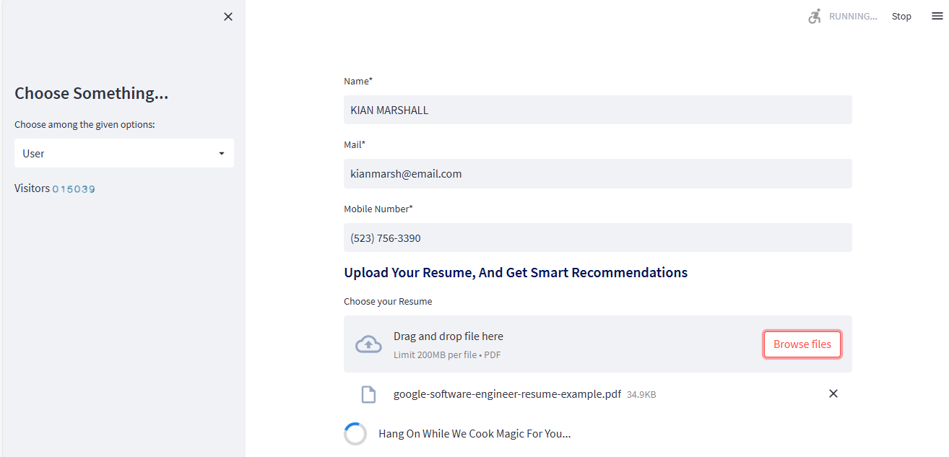
Figure 13 User Uploading Resume

User Resume Analysis:
The resume analysis which assesses various features like Experience level, Current Skills and recommended skills, Course recommendations, Resume tips and ideas, finally the resume score will be displayed. The Figure 14 shown the user experience level.
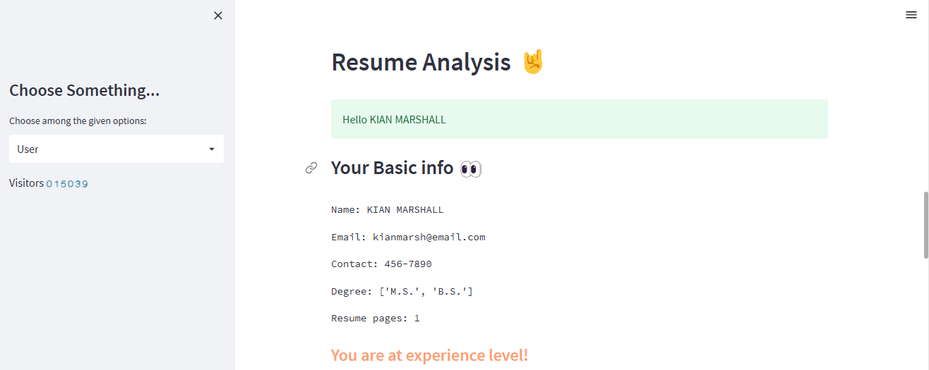
Figure 14 User Resume Analysis
The platform processes the resume then lists out current skills of user. These are shown on a Figure 15 in "Your Current Skills" Using the skills and experiences extracted out from the resume, it tries to predict what all roles a user is trying for. In the system has determined that most likely the user is interested in "Android App Development" positions (Figure 15). The platform then suggests more skills that the user might need to get a job in those specified field.
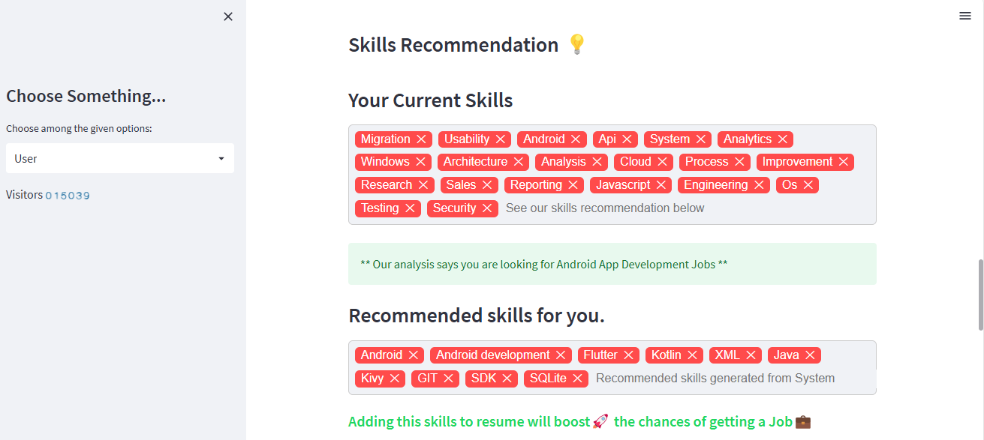
Figure 15 Skills Evaluation
Next, Course recommendation, there is a slider that allows the user to select how many course recommendations they want to see, ranging from 1 to 10. In the Figure 16, the user has chosen to view 5 course recommendations.
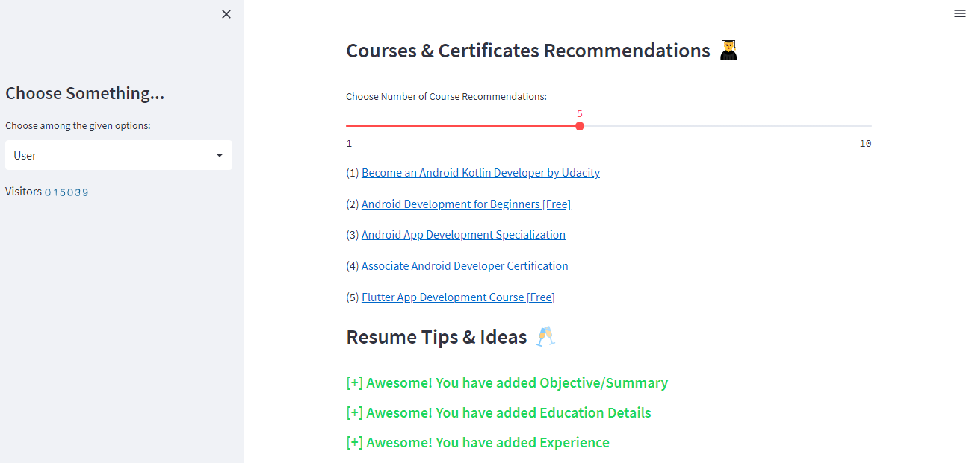
Figure 16 Course & Resume Tips
Below the course recommendations, there is a section providing positive feedback on the user's resume.
Resume Score is designed to provide a numerical evaluation of how well the user's resume matches with job they are targeting. Essential aspects of this stage comprise a thumbs up to the current resume content (Figure 17). The reason for this score is given based on resume content, which probably would include skills/certifications experiences and similar information that seems important to the job. Instead, the platform is intelligently designed to push a user toward writing an effective resume by giving them actionable advice.

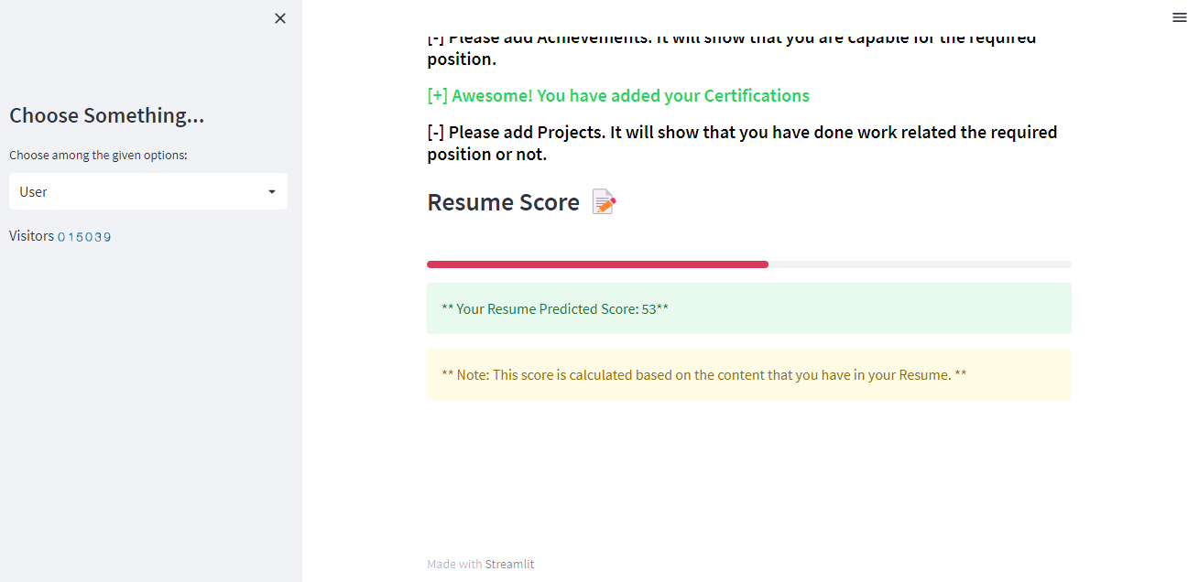
Figure 17 Resume Score

Feedback Screen
The user input is collected by a feedback form which consists of fields for a name, email as well as 1 to 5 rating and comments. Post-submittal, it tracks satisfaction data and encourages long-form feedback to iterate on user experiences.
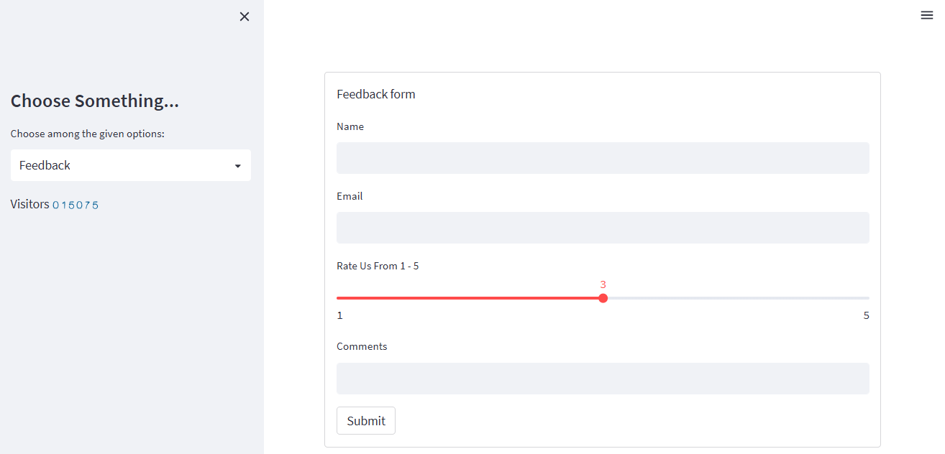
Figure 18 Feedback Form
Pie chart: Ratings since last visit are represented on a pie chart, with segments representing the distribution of user ratings — from 1 to 5.
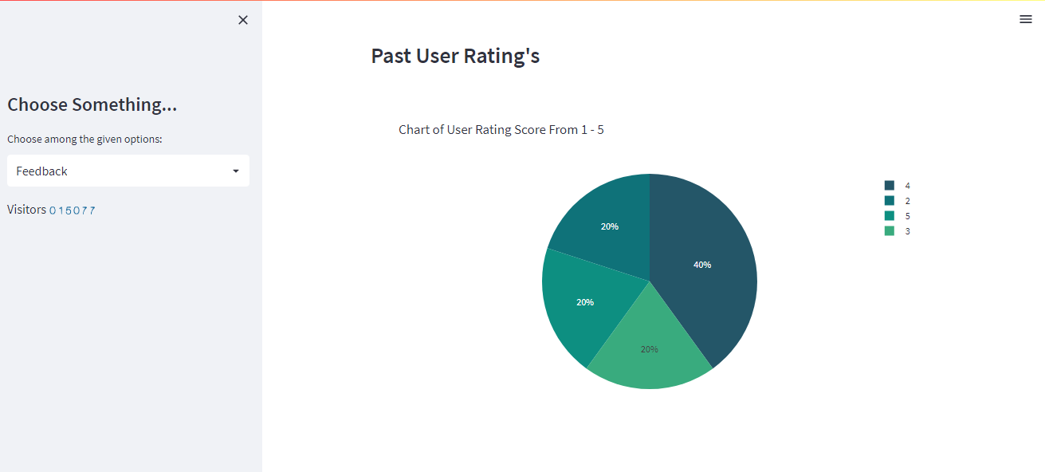
Figure 19 User rating Pie chart
User Comment’s section shows a selection of (anonymized) feedback from previous users, including their names, comments and ratings. This section provides a granular way for understanding user experiences by linking qualitative, text-based feedback to quantitative rating that reveals why users were either disappointed or pleased.
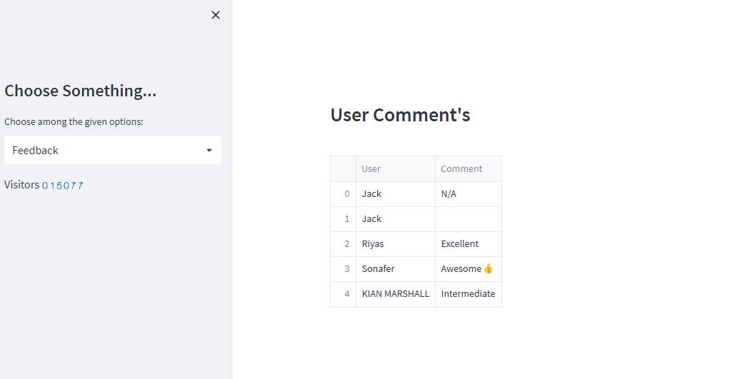
Figure 20 User Comment Table

Admin Screen
Login Interface:
This leads you to the main section of the page which asks users to log in their credentials. The username field is set to admin, and password file is given as admin123 It seems that these default credentials are for the admin area access.
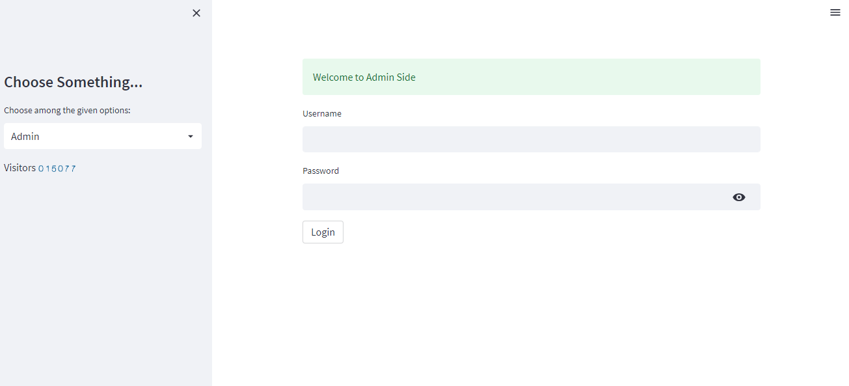
Figure 21 Admin Login Interface
Admin Dashboard:
After successfully logging, dashboard with a list of filtered resumes. Contracts Figure 22 given below is a table containing key information pulled from the resume of each candidate and predictions by the system. HR can also scan through these details to find matches based on certain criteria such as — with specific skills, the job role already predicted for that position or resume scores. Where necessary, they can then click through a candidate entry to see more details of the results: download additional reporting or reach out directly.
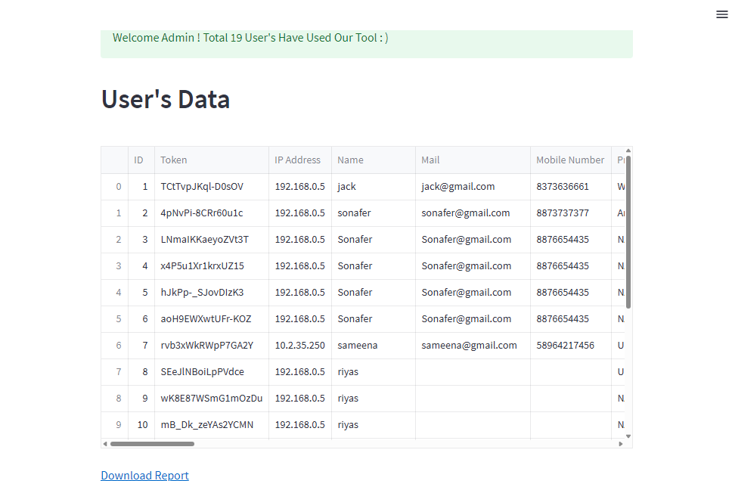
Figure 22 Admin view filtered resume’s report
Dashboard Table Sections It consist personal data i.e. ID, Name, Email and Mobile no. It also consists of technical details as to what he used while opening an exam: such usual things like candidate IP, OS version and server name. The way the system analyses the resume is visible here, with fields like predicted job roles; Resume scores and Predicted contact details. The table also includes real-world competencies, desired skills to develop and courses suggested. Lastly, it provides geolocation data detailing the city, state and country in which a candidate resides or is physically located at the time of answering questions (including latitude and longitude).
Feedback dashboard:
Once the users have entered their comments and rating on the comment page, this information is recorded by the system. Afterward, the feedback data (such as username, email, rating score, comments and time of submission) is displayed in a tabulated manner on admin page. The Figure 23 table shows to whom feedback was given, what they stated and when it was made so that an administrator can easily be able to understand this immediately. Moreover, on the feedback page there is a pie chart that summarizes the distribution of ratings visually which gives administrators an overview of how the service has been scored by users. This configuration assists in effective monitoring and assessment of client satisfaction which results into easy handling of any problems and enhancement of total user experience.
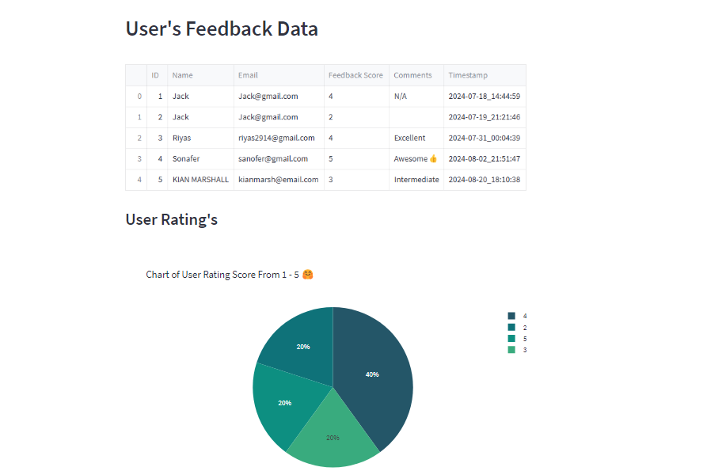
Figure 23 Feedback Data
It is possible that this figure 24 represents the corresponding fields of users’ career which were given depending on their skills to guide them in a career that fits into their skills. The presence of categories “NA” and “4” may indicate areas where the system could not confidently classify the skills into a known field.
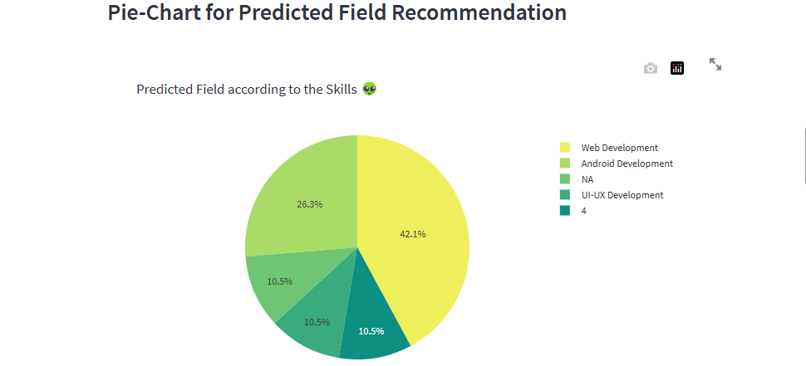
Figure 24 Predicted Field according to the Skills
Figure 25 probably provides an insight into how user experience levels are spread across, thus useful for tailoring content, recommendations, or resources according to their expertise.
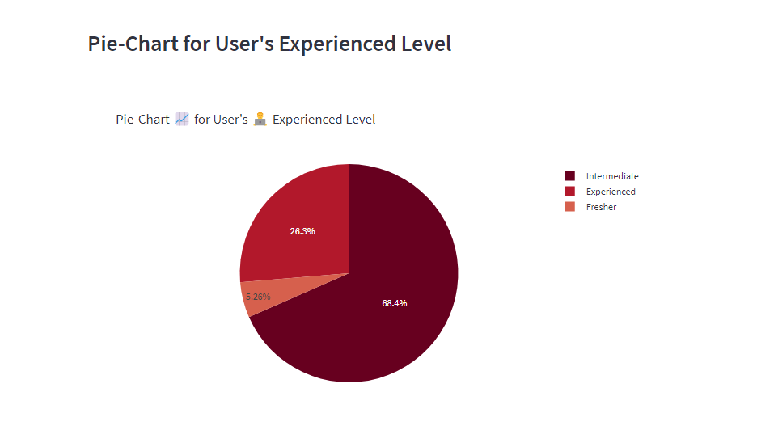
Figure 25 User's Experienced level
The Figure 26 visually shows how scores are concentrated with most resumes located at around 55 while other scores have fewer numbers. With this chart being used by the admin, resume distribution among different scoring ranges can be assessed.
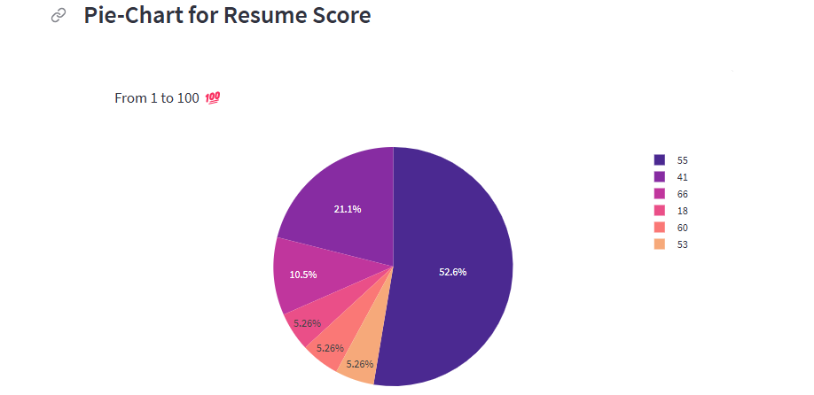
Figure 26 Resume Score

